Contents
Introduction 3
Methodology 5
Sampling 5
DNA extraction methods 7
PCR amplification 7
Sequencing 8
Bioinformatic and statistical processing 9
Reference libraries 10
Quality assurance 10
Results 11
Sequencing success and dataset overview 11
Genetic diversity 11
COI diversity 12
H3 diversity 13
Haplotype structure 13
COI haplotype network 13
H3 haplotype network 14
Geographic distribution of haplotypes 15
Population structure 18
Analysis of Molecular Variance (AMOVA) 18
Discriminant Analysis of Principal Components (DAPC) 19
Genetic differentiation 20
Isolation by Distance 22
Neutrality Tests 23
Discussion 24
Overall patterns of genetic diversity and structure 24
Methodological considerations 24
Interpretation of population genetic patterns 25
Genetic diversity and demographic signals 25
Mitochondrial vs nuclear patterns 26
Spatial structure and connectivity 27
Landscape history and habitat origin 28
Future directions 29
Conservation implications 30
References 31

Introduction
Habitat fragmentation is a major driver of biodiversity decline, particularly for species restricted to specialised environments (Fahrig, 2003; Haddad et al., 2015). As landscapes become increasingly divided, populations may become isolated, reducing gene flow and potentially limiting long-term evolutionary resilience (Frankham, 2003). Conservation genetics provides tools to assess how genetic diversity is distributed across landscapes and to evaluate whether populations remain connected or function as independent units (Allendorf et al., 2022).
The Fen Raft Spider Dolomedes plantarius is a wetland specialist of conservation concern within the United Kingdom (UK) and internationally (Milano et al., 2022), occurring in a limited number of fen and wetland systems characterised by specific hydrological conditions. These habitats are naturally patchy and often separated by unsuitable matrix habitat, raising questions about the extent to which populations remain genetically connected (Hanski, 1999). Although conservation management has focused on habitat protection and population monitoring, the genetic relationships among UK populations remain poorly resolved.
Understanding population connectivity is particularly important for species occupying fragmented habitats, where geographic proximity does not necessarily correspond to dispersal or gene flow (Crooks & Sanjayan, 2006; Lowe & Allendorf, 2010). Genetic data can therefore provide critical insight into whether populations operate as components of a larger metapopulation or represent partially isolated demographic units requiring independent management consideration (Holderegger & Wagner, 2008).
The aim of this study was to assess genetic diversity and structure across the current range of Dolomedes plantarius in East Sussex, United Kingdom, using mitochondrial (COI) and nuclear (H3) genetic markers. Mitochondrial DNA is maternally inherited and typically evolves more rapidly, providing insight into female lineage history and recent demographic processes, whereas nuclear markers such as Histone H3 are biparentally inherited and evolve more slowly, reflecting broader patterns of gene flow and longer-term population connectivity. In recent years, an increasing number of records have documented the species in outlying areas of the Pevensey Levels and in adjacent catchments where it had not previously been recorded. These sites were not initially considered discrete populations but were analysed as separate units to test whether genetic differentiation supports their recognition as independent components of the population. These observations raised questions regarding the origin of newly detected populations, specifically whether they represent recent colonisation events, previously undetected relict populations, or expansion from established core sites. Addressing these questions formed a central motivation for the present project and underpinned the award of funding for a population genetic assessment.
This work was conducted in parallel with the first comprehensive survey of the distribution of D. plantarius across the region since 1990, allowing genetic patterns to be interpreted alongside updated distributional data. Together, these complementary approaches provide an opportunity to evaluate connectivity among sites and to place recent range observations within a broader ecological and historical context.
The study fulfils the project's population genetic assessment objectives while establishing a baseline framework for forthcoming low-coverage whole-genome sequencing (lcWGS) analyses through the NERC Environmental Omics Facility (NEOF). These genomic analyses will extend the investigation of connectivity, demographic history, and population persistence at genome-wide resolution (Ellegren, 2014; Supple & Shapiro, 2018).

Methodology

Sampling
Specimens of D. plantarius were collected under license between 12 and 14 August 2025 from six locations in East Sussex, UK (AP = Ashburnham Place, BMF = Beech Mill Farm, CC = Carter’s Corner, CV = Combe Valley, EB = Eastbourne and PLR = Pevensey Levels Reserve). Ten specimens were collected per location. Surveys were conducted during daytime hours between approximately 09:00 and 18:00 GMT. Exact sampling locations were recorded using WGS84 geographic coordinates (Figure 1; Table 1).
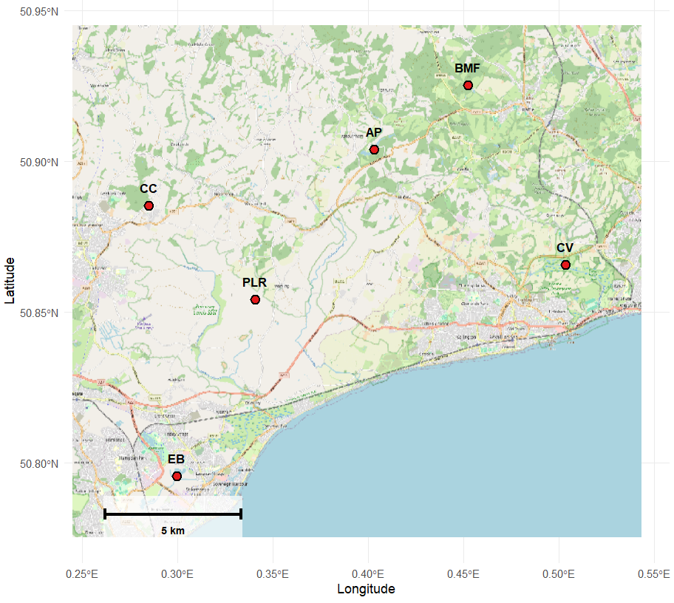
Figure 1 Map of the six sampling sites across East Sussex, UK. Red points indicate centred collection localities, labelled by site code. Coordinates are in WGS84 decimal degrees. Basemap © OpenStreetMap contributors.

Table 1 Centred WGS84 geographic coordinates of sampling sites
Site | Latitude (°N) | Longitude (°E)
AP | 50.903905 | 0.403013
BMF | 50.925170 | 0.452366
CC | 50.885174 | 0.284850
CV | 50.865634 | 0.503440
EB | 50.795588 | 0.299415
PLR | 50.854099 | 0.340748

Individuals were collected during targeted field surveys focused on locations with recent outlying records and sites representing the established core distribution, where the species has been consistently recorded at higher abundance. Sampling was aimed at comparing peripheral sites and the core population rather than obtaining statistically representative coverage across the entire known range. Sampling locations were selected to address questions relating to recent distributional changes and potential population expansion. Individuals were collected using sweep netting over vegetation and by shaking vegetation over a white tray within a suitable habitat. No traps were used. Following collection, specimens were handled individually to minimise the risk of cross-contamination. Live spiderlings were placed into individual collection tubes and transported to the laboratory after collection was complete. Upon arrival, samples were transferred immediately to a −80 °C freezer for long-term preservation prior to molecular analysis. The interval between field collection, preservation, and laboratory processing was minimised to maintain DNA integrity.

DNA extraction methods
Genomic DNA was extracted using the Qiagen DNeasy Blood and Tissue Kit following the manufacturer’s Animal Tissue Spin-Column protocol, with modifications optimised for small arachnid specimens. Due to the small body size and chitinous exoskeleton of the spiderlings, individuals were gently crushed prior to lysis to improve tissue disruption. The lysis stage was extended overnight (16–18 hours) at 56 °C to ensure complete tissue digestion. Prior to elution, the elution buffer was incubated directly on the spin-column membrane for five minutes at 55 °C, a modification that consistently improved DNA recovery.
DNA concentration and purity were assessed using a Nanophotometer spectrophotometer. Approximately 10% of samples were quantified to confirm successful DNA extraction and to assess yield consistency across extraction batches. Measured DNA concentrations ranged from 6.8 to 61.8 ng µL⁻¹ (mean 21.2 ng µL⁻¹), providing sufficient template DNA for downstream molecular analyses, with no indication of widespread degradation.
Strict contamination-control procedures were implemented throughout the extraction process. Samples were processed individually using sterile consumables and aerosol-resistant filter tips, and pre-PCR and post-PCR workflows were physically separated. Extraction blank controls were included with each extraction batch to monitor laboratory contamination.

PCR amplification
Two genetic loci were amplified to assess genetic diversity and structure: the mitochondrial cytochrome c oxidase subunit I (COI) gene and the nuclear Histone H3 (H3) gene.
Polymerase chain reactions (PCRs) were performed in 30 µL reaction volumes using 2× BioMix Red PCR Master Mix (Bioline). Each reaction contained 15 µL BioMix Red master mix, 1.0 µL of each primer (10 µM), 1.0 µL of template DNA, and nuclease-free water to a final volume of 30 µL. Following optimisation, each sample was amplified in a single reaction per locus.
COI amplification employed the primers LCO1490 (forward) (5′GGTCAACAAATCATAAAGATATTGG-3′) and HCO2198 (reverse) (5′TAAACTTCAGGGTGACCAAAAAATCA-3′) (Folmer et al., 1994). Thermal cycling consisted of an initial denaturation at 95 °C for three minutes, followed by 35 cycles of denaturation at 95 °C for 30 seconds, annealing at 47 °C for 45 seconds, and extension at 72 °C for one minute, with a final extension step of five minutes at 72 °C. The annealing temperature of 47 °C was selected following optimisation to maximise amplification consistency across samples.
Amplification of the H3 locus used primers H3aF (forward) (5′ATGGCTCGTACCAAGCAGACVGC-3′) and H3aR (reverse) (5′ATATCCTTRGGCATRATRGTGAC-3′) (Colgan et al., 1999). Cycling conditions consisted of an initial denaturation at 95 °C for three minutes, followed by 35 cycles of 95 °C for 30 seconds, 51 °C for 30 seconds, and 72 °C for 45 seconds, with a final extension step of five minutes at 72 °C and a hold at 4 °C.
PCR success was verified by electrophoresis on 1.5% agarose gels. Amplified products consistently produced single bands of the expected size, confirmed against a 100 bp DNA ladder run alongside samples, approximately 650 base pairs for COI and 330 base pairs for H3. Positive control reactions amplified as expected, while negative controls included in each amplification run showed no amplification, confirming successful contamination control.

Sequencing
PCR products demonstrating successful amplification were prepared for sequencing after visual verification of single bands on an agarose gel. Amplified products were quantified using a Nanophotometer spectrophotometer to confirm suitability for sequencing submission. PCR product concentrations ranged from approximately 605 to 647 ng µL⁻¹. As the sequencing facility required DNA concentrations of 20–25 ng µL⁻¹, samples were diluted prior to submission by combining 1 µL PCR product with 24 µL nuclease-free water to achieve the required loading concentration.
Samples were arranged on plates and submitted to Macrogen for Sanger sequencing using locus-specific forward primers (LCO1490 for COI and H3aF for H3). Cycle sequencing reactions, fluorescent dye chemistry, and capillary electrophoresis were performed by the sequencing provider using standard BigDye Terminator chemistry on an automated capillary sequencing platform (Applied Biosystems DNA Analyser or equivalent).
Forward-only sequencing was performed for most samples to ensure methodological consistency across all individuals included in the population genetic dataset. To assess sequence accuracy and confirm the reliability of forward reads, approximately 10% of samples for each marker were additionally sequenced in both directions. Bidirectional sequencing produced concordant base calls after alignment and trimming, validating that forward reads alone were sufficient for downstream analyses.
For Sanger sequencing, each successfully amplified sample yielded a single sequence read per locus, achieving the intended sequencing depth for all submitted samples. Of 60 initially sequenced individuals, 49 high-quality COI sequences and 59 H3 sequences were retained following quality control, while maintaining representation across all sampled sites.

Bioinformatic and statistical processing
Raw chromatogram files were manually inspected to assess sequence quality and to remove low-quality base calls from sequence termini. High-quality sequences were exported in FASTA format and aligned in MEGA (version 11; Tamura et al., 2021). Coding regions were verified by translation into amino acid sequences to confirm the correct reading frame and identify potential sequencing artefacts. Sequences showing persistent ambiguous base calls, poor chromatogram quality, or translation inconsistencies were excluded from downstream analyses.
Genetic diversity and structure were assessed using established population genetic approaches. Haplotype identification, numbers of segregating sites, haplotype diversity, and nucleotide diversity were calculated from aligned sequence datasets. Haplotype networks were constructed to visualise genealogical relationships among individuals and populations, and geographic population coordinates were incorporated into downstream analyses to examine spatial genetic structure and patterns of differentiation. Analyses were conducted using MEGA and R statistical software, with all population genetic analyses conducted in R (v4.5.2) (R Core Team, 2025). Aligned COI and H3 sequences were imported using the ape package v5.8.1 (Paradis & Schliep, 2019) and population assignments were defined a priori by sampling locality. Throughout the analytical procedures, sampling sites were treated as separate population units to enable formal testing of genetic structure among locations. At the time of sampling, these sites were not considered confirmed independent biological populations; rather, several represented outlying records whose population status was uncertain. Population-level analyses were therefore used explicitly to evaluate whether the sampled sites constitute a single continuous population or genetically differentiated units. Genetic diversity was characterised per population using haplotype diversity (Hd) and nucleotide diversity (π) calculated using pegas v1.4 (Paradis, 2010). Haplotype networks were constructed using a minimum spanning algorithm implemented using pegas, with haplotype frequencies visualised as population-coloured pie charts scaled by the square root of haplotype frequency. Pairwise genetic differentiation was estimated using Weir & Cockerham’s (1984) F_ST estimator, as implemented in hierfstat v0.5.11 (Goudet & Jombart, 2022), after converting DNAbin objects to the genind format using adegenet v2.1.11 (Jombart, 2008).
Analysis of molecular variance (AMOVA; Excoffier et al., 1992) was conducted using pegas v1.4, with pairwise genetic distances calculated under the Kimura two-parameter model (K80) and significance assessed using 999 permutations. Discriminant analysis of principal components (DAPC) was carried out using adegenet v2.1.11; the optimal number of principal components to retain was selected by cross-validation using xvalDapc with 30 replicates and a 90% training set. Isolation by distance was tested using a Mantel test (999 permutations) in vegan v2.7.2 (Oksanen et al., 2025), with genetic differentiation linearised as F_ST/(1 − F_ST) following Rousset (1997) and geographic distances calculated as Haversine distances using geosphere v1.5.20 (Hijmans, 2024). Neutrality was assessed per population using Tajima’s D (Tajima, 1989) as implemented using pegas v1.4. Geographic visualisation of haplotype distributions was produced using OpenStreetMap basemap tiles retrieved using maptiles v0.11.0 (Giraud, 2025), rendered with tidyterra v1.0.0 and terra v1.8.93, and annotated with population-level haplotype pie charts constructed using ggplot2 v4.0.2 (Wickham, 2016).

Reference libraries
Gene identity was verified through comparison with publicly available sequences deposited in GenBank (National Center for Biotechnology Information, NCBI), using BLAST searches against one representative sequence per haplotype (nine COI haplotypes; eleven H3 haplotypes). For COI, all nine representative sequences returned highest-identity matches to Dolomedes plantarius reference sequences (KX537002.1, 98.3-100% identity; OQ819316.1, 98.2–99.8% identity; KX536937.1, 98.5–100% identity), confirming correct species-level identification across all sampled haplotypes, including the rarer singleton haplotypes (BMF7, BMF9, CV4, CV7). For H3, no D. plantarius reference sequences are currently available on GenBank; the representative sequences instead returned highest-identity matches to congeneric species, D. tenebrosus (FJ607601.1, 96.2–97.3% identity; KY018377.1, 95.7-96.8% identity) and D. fimbriatus (KY190283.1, 97.1–98.2% identity) consistent with strong conservation of histone H3 across closely related taxa rather than any ambiguity in species assignment. No custom reference database or local sequence library was generated for this study, and population assignments were based solely on sampling locality rather than reference-based clustering.

Quality assurance
Quality assurance procedures were implemented throughout the laboratory, sequencing, and analytical stages to ensure the reliability of genetic results. During molecular laboratory work, extraction blank controls were included with each DNA extraction batch, and negative controls were incorporated into every PCR amplification run to monitor for potential contamination. Positive controls amplified as expected, and no amplification was observed in negative controls.
PCR products were evaluated using agarose gel electrophoresis to confirm successful amplification and expected fragment sizes prior to sequencing. Sequencing chromatograms were manually inspected to assess base-calling quality, and low-quality regions at sequence termini were trimmed before analysis. Approximately 10% of samples for each genetic marker were bidirectionally sequenced to confirm base-call consistency and validate the use of forward reads across the full dataset.
Bioinformatic quality control included verification of coding sequences by translating them into amino acid sequences to confirm correct reading frames and identify potential sequencing artefacts. Sequences with persistent ambiguous base calls, poor chromatogram quality, or translation inconsistencies were excluded from downstream analyses using consistent filtering criteria. Following quality filtering, retained sequences remained representative across all sampled populations, ensuring that downstream population genetic analyses were not biased by sequence exclusion.
No manual manipulation of genetic variation or alteration of aligned sequence data was undertaken beyond quality trimming (manual visual inspection of chromatograms to trim low-quality base calls from sequence termini) and removal of unreliable reads (sequences showing messy or overlapping signal, double peaks, or persistent ambiguous base calls were excluded). Statistical analyses were conducted using reproducible workflows implemented in R, ensuring analytical transparency and repeatability.
All laboratory and analytical procedures followed established population-genetic best practices to ensure the robustness and reproducibility of conservation-relevant genetic inferences.

Results

Sequencing success and dataset overview
A total of 60 individuals were sequenced for both genetic markers. Following quality control filtering, 49 high-quality COI sequences and 59 H3 sequences were retained for downstream analyses. Sequence filtering removed chromatograms with persistent ambiguous base calls or poor read quality while maintaining representation across all sampled sites.
Successful amplification and sequencing were obtained from all six sampling locations (AP, BMF, CC, CV, EB and PLR), which were analysed as provisional population units to evaluate whether outlying sites represent genetically distinct populations.

Genetic diversity
Genetic diversity was quantified for six sites using mitochondrial COI and nuclear H3 markers (Table 2).
Table 2 Genetic diversity statistics by population
Marker | Population | N | Haplotypes | Hd | π
COI | AP | 6 | 3 | 0.6000 | 0.001433
 | BMF | 8 | 5 | 0.7857 | 0.006789
 | CC | 10 | 2 | 0.2000 | 0.000331
 | CV | 7 | 3 | 0.5238 | 0.002676
 | EB | 9 | 4 | 0.7778 | 0.002571
 | PLR | 9 | 2 | 0.2222 | 0.002204
H3 | AP | 10 | 2 | 0.2000 | 0.003390
 | BMF | 9 | 4 | 0.5833 | 0.004896
 | CC | 10 | 5 | 0.7556 | 0.007684
 | CV | 9 | 4 | 0.5833 | 0.003955
 | EB | 10 | 5 | 0.8222 | 0.008889
 | PLR | 11 | 6 | 0.8364 | 0.009738
Note. N= Number of individuals

COI diversity
Across 49 COI sequences, nine haplotypes were detected. Haplotype diversity (Hd) ranged from 0.2000 in CC to 0.7857 in BMF. Nucleotide diversity (π) ranged from 0.000331 in CC to 0.006789 in BMF. At the population level, haplotype richness ranged from 2 (CC and PLR) to 5 (BMF).

H3 diversity
Across 59 H3 sequences, 11 haplotypes were detected. Haplotype diversity (Hd) ranged from 0.2000 in AP to 0.8364 in PLR. Nucleotide diversity (π) ranged from 0.003390 in AP to 0.009738 in PLR. At the population level, haplotype richness ranged from 2 (AP) to 6 (PLR).

Haplotype structure

COI haplotype network
The COI haplotype network identified nine haplotypes arranged around a single dominant central haplotype shared among multiple populations (Figure 2)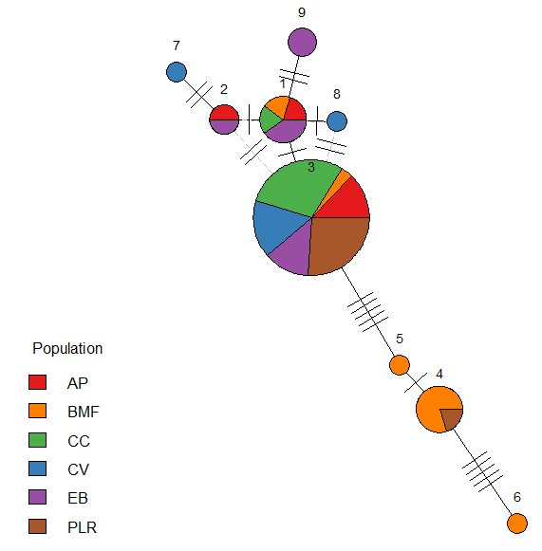
Figure 2 COI Haplotype network
This central haplotype was represented by individuals from all six sampling locations. Several lower-frequency haplotypes radiated from the central haplotype and were separated by one to multiple mutational steps. A subset of haplotypes occurred exclusively within single populations, indicating the presence of population-specific variants. Peripheral haplotypes were represented by fewer individuals than the central haplotype.

H3 haplotype network
The H3 haplotype network comprised 11 haplotypes, forming a more interconnected network (Figure 3).
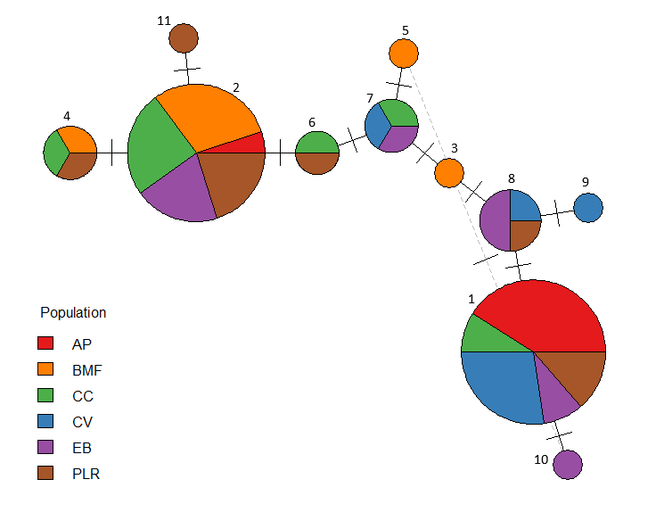
Figure 3 H3 Haplotype network
Multiple haplotypes were shared among populations, and several intermediate haplotypes connected major nodes via single mutational steps. Compared with the COI network, haplotypes were more evenly distributed among populations, and long mutational branches were less common. No single haplotype dominated across all populations.

Geographic distribution of haplotypes
Geographic visualisation of haplotype frequencies revealed spatial variation in haplotype composition among sampling locations for both genetic markers.
For COI, populations differed in relative haplotype frequencies, with several haplotypes occurring at single locations while others were shared among multiple sites (Figure 4)
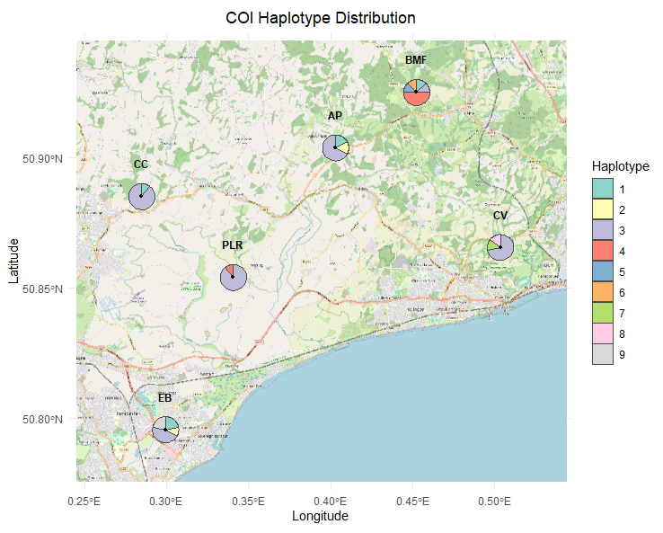
Figure 4 Geographical distribution of COI haplotypes
For H3, haplotypes were broadly distributed across populations, with multiple sites containing mixtures of haplotypes rather than single dominant variants (Figure 5).
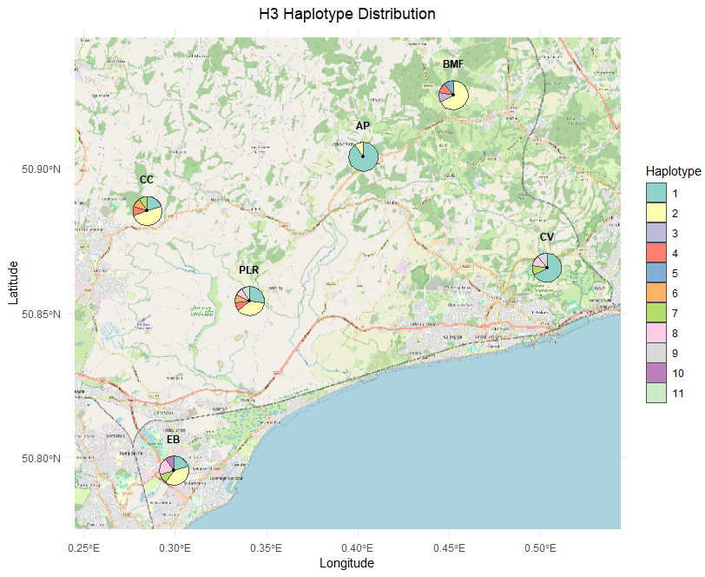
Figure 5 Geographical distribution of H3 haplotypes

Population structure

Analysis of Molecular Variance (AMOVA)
Analysis of molecular variance revealed significant genetic structure among populations for both genetic markers (Table 3).
Table 3 AMOVA results
Marker | Source | Variance Component | % Variation | ΦST | p-value
COI | Among populations | 1.19 ×10⁻⁵ | 53.0% | 0.530 | <0.001
 | Within populations | 1.06 ×10⁻⁵ | 47.0%
H3 | Among populations | 2.63 ×10⁻⁵ | 37.1% | 0.371 | <0.001
 | Within populations | 4.47 ×10⁻⁵ | 62.9%
For the COI dataset, 53.0% of total genetic variation was attributed to differences among populations (Φ_ST = 0.530, p < 0.001), with the remaining 47.0% occurring within populations.
For the H3 dataset, 37.1% of genetic variation occurred among populations (Φ_ST = 0.371, p < 0.001), while 62.9% was distributed within populations.

Discriminant Analysis of Principal Components (DAPC)
Discriminant Analysis of Principal Components was used to visualise genetic clustering among populations.
For the COI dataset, individuals formed a strongly separated cluster along discriminant function 1, with one population (BMF) clearly differentiated from the remaining populations, which showed substantial overlap (Figure 6).
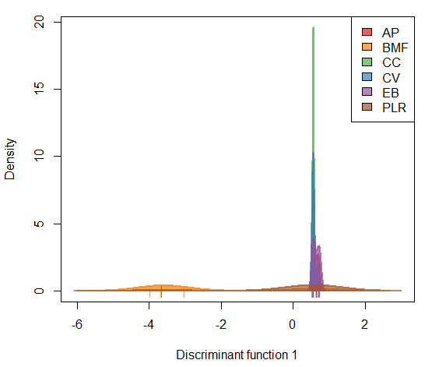
Figure 6 DAPC analysis of COI

For the H3 dataset, clustering was less distinct. Multiple populations showed partial overlap along the first discriminant axis, and separation among groups was reduced compared with that observed with the COI marker (Figure 7).
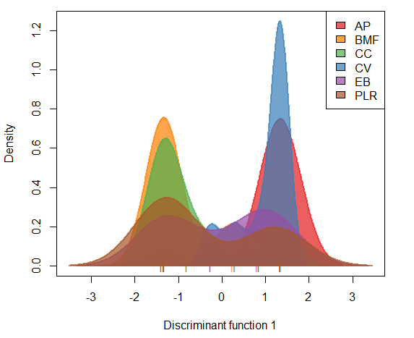
Figure 7 DAPC analysis of H3

Genetic differentiation
Pairwise genetic differentiation among populations was assessed using F_ST estimates for both COI and H3 markers.

COI
Pairwise F_ST values for COI (Table 4) were generally low among most population comparisons, with values close to zero or slightly negative. One population (BMF) showed greater differentiation than the other populations, with pairwise F_ST values ranging from 0.061 to 0.088. All remaining pairwise comparisons ranged between −0.004 and 0.010.
Table 4 Pairwise FST values for COI
 | AP | BMF | CC | CV | EB | PLR
AP | — | 0.081 | 0.001 | -0.004 | -0.001 | 0.002
BMF |  | — | 0.088 | 0.080 | 0.088 | 0.061
CC |  |  | — | 0.001 | 0.007 | 0.000
CV |  |  |  | — | 0.001 | 0.002
EB |  |  |  |  | — | 0.010
PLR |  |  |  |  |  | —

H3
Pairwise F_ST values for H3 (Table 5) showed a wider range of differentiation among populations. Values ranged from −0.011 to 0.158, with several population pairs showing higher differentiation than others. The highest differentiation was observed between AP and BMF (F_ST = 0.158).
Table 5 Pairwise FST values for H3
 | AP | BMF | CC | CV | EB | PLR
AP | — | 0.158 | 0.110 | -0.003 | 0.046 | 0.074
BMF |  | — | -0.007 | 0.146 | 0.027 | 0.005
CC |  |  | — | 0.097 | 0.002 | -0.011
CV |  |  |  | — | 0.034 | 0.063
EB |  |  |  |  | — | -0.009
PLR |  |  |  |  |  | —

Isolation by Distance
Isolation by distance was evaluated using Mantel tests comparing linearised genetic differentiation (F_ST/(1 − F_ST)) with geographic distance among populations (Figure 8).
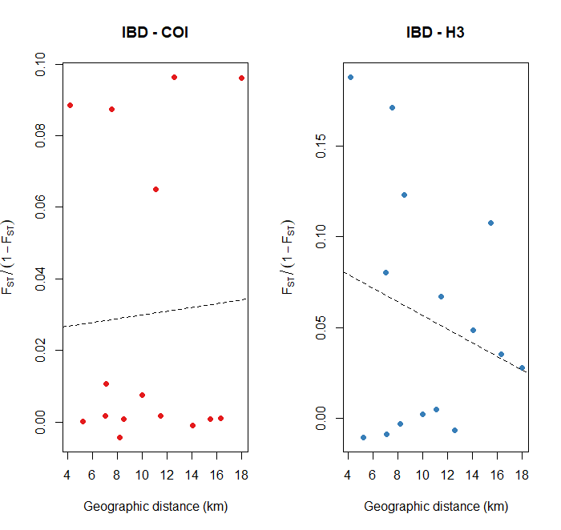
Figure 8 Isolation-by-distance plots showing the relationship between geographic distance and linearised genetic differentiation for COI (left) and H3 (right). Dashed lines indicate linear regression trends.
No significant relationship between genetic and geographic distance was detected for either genetic marker.
For COI, the Mantel test showed a weak positive correlation that was not statistically significant (r = 0.051, p = 0.410).
For H3, the Mantel test indicated a negative, non-significant correlation between genetic and geographic distance (r = −0.235, p = 0.800).
Scatterplots showed no consistent increase in genetic differentiation with increasing geographic distance.

Neutrality Tests
Neutrality was assessed for each population using Tajima’s D statistics (Table 6).
For the COI marker, Tajima’s D values ranged from −1.728 (PLR) to 0.231 (EB).
For the H3 marker, values ranged from −1.741 (AP) to 1.939 (EB).
Across both markers, Tajima’s D values varied among populations and were not statistically significant.
Table 6 Tajima’s D by population
Marker | Population | Tajima’s D
COI | AP | -0.050
 | BMF | -0.159
 | CC | -1.112
 | CV | -1.024
 | EB | 0.231
 | PLR | -1.728
H3 | AP | -1.741
 | BMF | -0.910
 | CC | 0.284
 | CV | -0.843
 | EB | 1.939
 | PLR | 0.820

Discussion

Overall patterns of genetic diversity and structure
This study examined patterns of genetic diversity and structure across six sampling locations of D. plantarius in East Sussex, including sites within the long-recognised Pevensey Levels core and several recently recorded outlying locations. A range of complementary analyses provided evidence of genetic structuring, which was more pronounced in the mitochondrial COI marker than in the nuclear H3 locus, despite the relatively small geographic scale of sampling. Genetic variation was unevenly distributed among sites, with a substantial proportion of total variance attributable to differences among locations rather than within them. Taken together, these findings suggest that the East Sussex system does not function as a single homogeneous population but instead comprises partially differentiated genetic units whose connectivity varies across the landscape.

Methodological considerations
The use of complementary mitochondrial and nuclear markers provides a widely applied framework for assessing population genetic structure in non-model organisms. Mitochondrial COI remains one of the commonly used loci for detecting lineage structure and recent demographic processes, while nuclear protein-coding genes, such as Histone H3, provide an independent perspective on biparentally inherited variation (Avise, 2000; Colgan et al., 1999; Folmer et al., 1994). Combining these marker types allows comparison between maternal lineage history and genome-wide connectivity signals, an approach frequently applied in arachnid and other invertebrate population studies (e.g. Crews & Gillespie, 2010; Planas et al., 2013).
Marker-based approaches inevitably represent only a fraction of total genomic variation, yet they remain valuable for establishing baseline population structure, particularly where conservation constraints limit destructive sampling. The concordance among multiple analytical methods in the present study suggests that the inferred patterns are unlikely to result from marker-specific artefacts.
Several analytical considerations warrant discussion. Measures of genetic diversity included both haplotype diversity (Hd) and nucleotide diversity (π), which capture different properties of variation. Haplotype diversity reflects the probability that two individuals possess different haplotypes and therefore describes haplotype richness and evenness, whereas nucleotide diversity measures the average sequence divergence among individuals (Nei, 1987). Consequently, populations may exhibit high haplotype diversity but low nucleotide diversity when many closely related haplotypes are present, a pattern often associated with historical population expansion following a reduction in population size (Grant & Bowen, 1998).
Discriminant Analysis of Principal Components (DAPC) was used to visualise clustering among predefined populations. DAPC does not assume Hardy-Weinberg equilibrium and is therefore well suited to structured populations; however, clustering outcomes may be influenced by unequal sample sizes, and results should be interpreted alongside complementary statistics rather than in isolation (Jombart et al., 2010). Similarly, pairwise F_ST estimates provide useful comparative measures of differentiation but may benefit from permutation-based significance testing in future analyses to further quantify statistical support (Weir & Cockerham, 1984).
Together, these methodological choices follow established practice in molecular ecology and enable cautious yet informative inference about population connectivity.

Interpretation of population genetic patterns
Across all analyses, genetic structuring was detected, though its strength varied between markers and population pairs. Multiple haplotypes were recovered from both mitochondrial and nuclear loci, demonstrating that populations are genetically variable rather than homogeneous despite their restricted distribution.

Genetic diversity and demographic signals
Variation in haplotype and nucleotide diversity among populations suggests differences in local demographic history, effective population size, or historical connectivity. Importantly, haplotype diversity did not consistently correlate with nucleotide diversity, suggesting that some populations harbour multiple closely related haplotypes rather than deeply divergent lineages. Such patterns are consistent with alternative demographic scenarios, including historical population reduction followed by expansion or long-term persistence of ancestral variation (Avise, 2000; Grant & Bowen, 1998).
Tajima’s D values were generally consistent with neutral expectations and did not indicate strong recent bottlenecks or selective sweeps detectable at these loci. However, with per-population sample sizes of six to eleven individuals, the statistical power to detect demographic signals is limited, and these results should be interpreted with caution rather than as positive evidence for long-term persistence.

Mitochondrial vs nuclear patterns
Contrasting genetic patterns were observed between the mitochondrial COI marker and the nuclear H3 locus, consistent with the differing inheritance modes and evolutionary rates of mitochondrial and nuclear DNA introduced above. The COI haplotype network was characterised by a dominant central haplotype surrounded by several low-frequency derivatives, a pattern commonly associated with shared ancestry followed by local divergence among sites. In contrast, the H3 network exhibited a more interconnected structure, with haplotypes broadly shared across locations and weaker population separation.
Such differences between mitochondrial and nuclear markers are expected. Mitochondrial DNA is maternally inherited, effectively haploid, and typically has a smaller effective population size than nuclear DNA, allowing lineage sorting and genetic differentiation to occur more rapidly (Avise, 2000; Ballard & Whitlock, 2004). Nuclear loci, inherited from both parents and subject to recombination, generally retain signatures of gene flow over longer timescales and therefore often display weaker spatial structure (Zink & Barrowclough, 2008). The more structured COI pattern observed here likely reflects sensitivity to female-mediated dispersal history, whereas the broader sharing of H3 haplotypes suggests that some level of biparental genetic connectivity persists among sites.
One plausible explanation is that certain locations were established by relatively small numbers of founding females, producing reduced mitochondrial diversity through founder effects, while continued mating with multiple males maintained nuclear genetic variation. Similar mitochondrial–nuclear discordance has been reported in several spider systems and other invertebrates, where colonisation dynamics, sex-biased dispersal, or stochastic founder events generate stronger structure in mitochondrial markers than in nuclear loci (Crews & Gillespie, 2010; Planas et al., 2013). Taken together, the contrasting signals from COI and H3 suggest a history of colonisation followed by ongoing, but limited, connectivity among sites. Rather than indicating complete isolation, the combined marker evidence supports a scenario in which populations share historical ancestry yet experience restricted contemporary gene flow within a fragmented wetland landscape. An alternative, non-exclusive explanation is that some sites have become more recently isolated than the marker data can currently resolve; the genetic signal of such recent isolation may not yet be fully detectable and is expected to become more apparent in subsequent generations.

Spatial structure and connectivity
Across sites, haplotype distributions revealed a mixture of shared and private genetic variants. The presence of private haplotypes indicates local divergence and restricted gene flow at some locations, while the absence of any site composed entirely of unique haplotypes suggests that complete historical isolation has not occurred. Instead, the system appears to retain signatures of shared ancestry alongside emerging differentiation.
Multiple analytical approaches converged on this interpretation. AMOVA demonstrated that a substantial proportion of genetic variance was attributable to differences among sites, and both DAPC clustering and pairwise F_ST estimates indicated uneven differentiation across the landscape. Importantly, differentiation was not uniformly distributed: certain sites contributed disproportionately to overall structure, whereas others showed substantial overlap. This pattern is consistent with spatially heterogeneous connectivity rather than simple isolation across the region.
Notably, isolation-by-distance was not detected for either marker. Genetic differentiation did not increase predictably with geographic distance, suggesting that linear separation alone does not explain population structure within this system. For habitat specialists occupying fragmented wetlands, dispersal opportunity is often governed more strongly by habitat configuration, patch connectivity, and landscape permeability than by Euclidean distance (Baguette et al., 2013; Hanski, 1999; Lowe & Allendorf, 2010). In this context, the Sussex landscape likely functions as a network of habitat patches centred on the Pevensey Levels, with connectivity influenced by wetland continuity, hydrological links, and local habitat quality.
This patch-based pattern is consistent with metapopulation dynamics, in which populations persist within a mosaic of semi-connected habitat fragments subject to variable dispersal and local extinction-colonisation processes (Hanski, 1999; Levins, 1969). Some peripheral sites may now experience reduced contemporary connectivity relative to historical conditions, particularly under modern landscape fragmentation. However, the retention of multiple haplotypes at all sampled locations indicates that genetic diversity has not been entirely eroded, although standing genetic diversity of this kind can mask more subtle, ongoing genetic erosion in fragmented populations, and this is best assessed directly once genome-wide data are available. Even sites suspected to have experienced founder events or restricted dispersal retain measurable variation, suggesting that evolutionary potential persists across the system, though this should be interpreted as a present-day snapshot rather than a guarantee of long-term resilience.
Taken together, the evidence supports a model of fragmented but not fully isolated populations, with connectivity shaped more by habitat structure than by geographic distance alone.

Landscape history and habitat origin
Interpreting genetic structure alongside habitat history provides additional context for understanding spatial patterns across the Sussex system. The Pevensey Levels represent the long-recognised centre of distribution, with sustained records and relatively continuous wetland habitat. In contrast, several of the sampled sites differ markedly in origin and landscape setting, which are likely to influence their genetic composition.
The artificial pond systems at BMF and CC are of relatively recent anthropogenic origin and are spatially separated from the main wetland complex. Both systems were established in the early 2000s (exact dates are being confirmed with landowners), a timescale consistent with either reduced or potentially absent subsequent gene flow following initial colonisation. The genetic differentiation observed at these sites may therefore reflect founder effects involving a limited number of colonising individuals, and consequently a restricted subset of the haplotypes present in the source population, rather than ongoing isolation following repeated dispersal events. Interestingly, landowners at both BMF and CC independently reported that landscaping contractors operating across multiple sites in the region, including the Pevensey Levels, may have inadvertently transported spiders on tools, machinery, or plant material (the landowner, personal communication, 2025). Although anecdotal, these accounts provide a plausible anthropogenic dispersal mechanism consistent with the observed genetic signatures: the establishment of new populations from small numbers of inadvertently translocated individuals originating from the core Pevensey Levels population. Human-mediated dispersal of invertebrates through horticultural and landscaping activities has been documented in other systems and can produce genetic patterns that closely resemble natural founder events (Hulme et al., 2008).
The basis for this spatial separation differs between the two sites. Carter’s Corner lies on the fringes of the Levels proper, divided from the main wetland complex by the A271, a barrier of moderate but not absolute significance; a documented case from nearby Magnum Down shows that garden ponds in this general area can retain hydrological connectivity to the Pevensey Levels via roadside culverts, illustrating that several alternative colonisation routes remain plausible for the Carter’s Corner cluster. Beech Mill Farm presents a more clear-cut case: it has no plausible physical wetland connection to the Levels, and the intervening distance, expanse of Wealden woodland, and urbanisation make even a historical connected-outlier scenario implausible, leaving founder-driven establishment from translocated individuals as the most likely explanation. For both sites, habitat configuration and the presence of dispersal barriers are likely to be more relevant to genetic outcomes than straight-line geographic distance alone; this is illustrated by Ashburnham Place, which, despite being similarly distant from the core of the Levels, retains greater continuity of grazing habitat via the Ash Bourne stream (which also passes under the A271), and might therefore be expected to show different genetic patterns from BMF and CC were it to be sampled.
Such patterns are commonly observed in newly established habitats, where small founding sizes can generate detectable structure even in the absence of long-term isolation (Frankham, 2003; Nei, 1987). However, these sites are not genetically uniform; the presence of multiple haplotypes indicates that either the founding groups were not genetically homogeneous or that ongoing dispersal has been limited. It should be noted that the differentiation of BMF is marker-dependent: COI pairwise FST values are consistently elevated for BMF (0.061–0.088 against all other sites), whereas H3 pairwise values for BMF are heterogeneous, with some comparisons showing high differentiation (AP–BMF: FST = 0.158) and others near zero (BMF–CC: FST = −0.007; BMF–PLR: FST = 0.005). The founder-event interpretation is therefore most strongly supported for maternal lineages, and the nuclear evidence is more equivocal.
In contrast, naturally occurring wetland sites show greater haplotype sharing, suggesting historical connectivity within a broader wetland network. This pattern is consistent with a landscape in which hydrological continuity and habitat adjacency once facilitated dispersal among sites that are now more fragmented.
Combe Valley occupies an intermediate position. Although it supports SSSI quality grazing marsh, it is geographically separated from the Pevensey Levels and other sampled sites. In practical terms, this means CV sits within an entirely separate catchment, separated from the Pevensey Levels by elevated land whose lower-lying parts are occupied by the 5.5 km linear extent of Bexhill-on-Sea. The H3 data detect some differentiation at CV, particularly from BMF (FST = 0.146), whereas COI pairwise FST values for CV are negligible against all sites except BMF (range: −0.004 to 0.002), with the elevated CV–BMF value (FST = 0.080) reflecting BMF's broader pattern of COI divergence rather than a CV-specific signal, indicating little maternal lineage differentiation distinct to CV itself. Shared haplotypes and the absence of deeply divergent lineages do not support the hypothesis that CV represents a long-isolated remnant population. Rather, its pattern is more consistent with historical connectivity followed by increasing spatial separation, with habitat configuration likely exerting a stronger influence on gene flow than geographic distance alone. Deliberate introduction cannot be entirely excluded as an alternative explanation for the CV population, although no direct evidence for this was identified during the present study.
Taken together, these findings suggest that present-day structure reflects the combined effects of historical wetland continuity and more recent anthropogenic fragmentation. Artificially established sites appear compatible with founder-driven differentiation, while natural wetlands retain signatures of past connectivity. The East Sussex system, therefore, illustrates how both the history of colonisation and landscape modification contribute to shaping contemporary genetic patterns.

Future directions
This study provides the first genetic baseline for the Sussex D. plantarius system and addresses a central objective of the funded project: evaluating genetic relationships between the Pevensey Levels core and outlying sites where the species has recently been recorded. The results establish a working hypothesis of core–satellite structure rather than a collection of independently isolated populations. As such, they serve as a foundation for the forthcoming low-coverage whole-genome sequencing (lcWGS) analyses being undertaken by the NERC Environmental Omics Facility (NEOF).
Genome-wide data will substantially extend the scope of inference possible from the present marker-based approach. In particular, lcWGS will permit estimation of effective population size (N_e), reconstruction of historical demography, finer-scale analysis of genetic diversity through genome-wide heterozygosity estimates, and more rigorous testing of the strength and direction of connectivity among sites (Lou et al., 2021). These analyses should also help resolve whether outlying sites represent recent colonisation events, persistent subpopulations, or emerging independent genetic units, questions that the current dataset can frame but not definitively answer. Additionally, genomic data may reveal signals of locally adaptive variation that are invisible to the small number of loci examined here (Hohenlohe et al., 2021). The present marker-based results will act as an interpretative baseline against which genome-wide patterns can be compared, and concordance or discordance between the two scales of analysis will itself be informative about the timescales over which population processes have operated.
Ultimately, integrating genomic findings with concurrent regional distribution surveys, ongoing demographic monitoring, and available habitat and land-use change data will be needed to build a more complete picture of population dynamics and long-term viability across the East Sussex landscape.

Conservation implications
Based on the evidence presented here, the East Sussex D. plantarius system is best interpreted as a fragmented but semi-connected metapopulation centred on the Pevensey Levels. Outlying sites appear most consistent with colonisation from the core, followed by partial isolation, rather than representing confirmed remnant lineages of independent origin. An encouraging finding is that measurable genetic diversity has been retained across all sampled sites despite habitat fragmentation, suggesting that evolutionary potential has not yet been critically eroded.
The primary management priority arising from these results is preventing further isolation. Because diversity persists across the system, the emphasis should be on maintaining existing connectivity before genetic erosion occurs, rather than on restoring variation that has already been lost. This distinction has practical implications: management effort is likely to be most effective if directed toward sustaining dispersal pathways and habitat continuity across the landscape (Frankham et al., 2017).
Artificially established sites such as BMF and CC, which appear to have been founded by limited numbers of colonists, may be more vulnerable to genetic drift and stochastic loss of variation than larger or better-connected sites. Nevertheless, these sites still contribute to overall metapopulation diversity and should not be dismissed as genetically expendable. Management at these locations should focus on maintaining habitat quality, avoiding local extinction, and facilitating natural dispersal where feasible. Where artificial habitats are maintained or created in future, consideration of genetic connectivity, for example, through spatial placement relative to existing populations, may help to reduce the risk of further founder-driven differentiation (Weeks et al., 2011).
Natural wetland sites retain clearer signatures of historical connectivity and are likely to play a disproportionate role in sustaining gene flow across the system. Priority actions at these locations include maintaining hydrological continuity, protecting existing habitat networks, and enhancing landscape permeability where opportunities arise.
Combe Valley presents a somewhat ambiguous case. The H3 data detect some differentiation at this site, but the COI data show negligible divergence, and there is no strong evidence at the current marker resolution for long-term independent remnant status. Pending genomic confirmation, Combe Valley should be managed as a functionally connected peripheral unit rather than as an isolated population requiring independent genetic management.
More broadly, these findings underscore that population boundaries in fragmented systems should not be assumed solely on the basis of geographic separation. Effective management of D. plantarius in East Sussex will need to recognise differing colonisation histories among sites, variable levels of connectivity, and the landscape context in which each site is embedded. A shift from purely site-based protection toward landscape-scale management aimed at sustaining metapopulation resilience offers the most pragmatic framework for conserving this species across its East Sussex range (Opdam & Wascher, 2004).

References
Allendorf, F. W., Funk, W. C., Aitken, S. N., Byrne, M., Luikart, G., & Antunes, A. (2022). Conservation and the Genomics of Populations. Oxford University Press. https://doi.org/10.1093/oso/9780198856566.001.0001
Avise, J. C. (2000). Phylogeography. Harvard University Press. JSTOR. https://doi.org/10.2307/j.ctv1nzfgj7
Baguette, M., Blanchet, S., Legrand, D., Stevens, V. M., & Turlure, C. (2013). Individual dispersal, landscape connectivity and ecological networks. Biological Reviews of the Cambridge Philosophical Society, 88(2), 310–326. https://doi.org/10.1111/brv.12000
Ballard, J. W. O., & Whitlock, M. C. (2004). The incomplete natural history of mitochondria. Molecular Ecology, 13(4), 729–744. https://doi.org/10.1046/j.1365-294x.2003.02063.x
Colgan, D., McLauchlan, A., Wilson, G., Livingston, S., Edgecombe, G., Macaranas, J., Cassis, G., & Gray, M. (1999). Histone H3 and U2 snRNA DNA sequences and arthropod molecular evolution. Australian Journal of Zoology, 46, 419–437. https://doi.org/10.1071/ZO98048
Crews, S. C., & Gillespie, R. G. (2010). Molecular systematics of Selenops spiders (Araneae: Selenopidae) from North and Central America: implications for Caribbean biogeography: SYSTEMATICS AND BIOGEOGRAPHY OF SELENOPS. Biological Journal of the Linnean Society, 101(2), 288–322. https://doi.org/10.1111/j.1095-8312.2010.01494.x
Crooks, K. R., & Sanjayan, M. (Eds). (2006). Connectivity Conservation. Cambridge University Press. Cambridge Core. https://doi.org/10.1017/CBO9780511754821
Ellegren, H. (2014). Genome sequencing and population genomics in non-model organisms. Trends in Ecology & Evolution, 29(1), 51–63. https://doi.org/10.1016/j.tree.2013.09.008
Excoffier, L., Smouse, P. E., & Quattro, J. M. (1992). Analysis of molecular variance inferred from metric distances among DNA haplotypes: Application to human mitochondrial DNA restriction data. Genetics, 131(2), 479–491. https://doi.org/10.1093/genetics/131.2.479
Fahrig, L. (2003). Effects of Habitat Fragmentation on Biodiversity. Annual Review of Ecology, Evolution, and Systematics, 34(1), 487–515. https://doi.org/10.1146/annurev.ecolsys.34.011802.132419
Folmer, O., Black, M., Hoeh, W., Lutz, R., & Vrijenhoek, R. (1994). DNA primers for amplification of mitochondrial cytochrome c oxidase subunit I from diverse metazoan invertebrates. Molecular Marine Biology and Biotechnology, 3(5), 294–299.
Frankham, R. (2003). Genetics and conservation biology. Comptes Rendus Biologies, 326(SUPPL. 1), 22–29. https://doi.org/10.1016/S1631-0691(03)00023-4
Frankham, R., Ballou, J. D., Ralls, K., Eldridge, M., Dudash, M. R., Fenster, C. B., Lacy, R. C., & Sunnucks, P. (2017). Genetic Management of Fragmented Animal and Plant Populations. Oxford University Press. https://doi.org/10.1093/oso/9780198783398.001.0001
Giraud, T. (2025). maptiles: Download and Display Map Tiles. https://doi.org/10.32614/CRAN.package.maptiles
Goudet, J., & Jombart, T. (2022). hierfstat: Estimation and Tests of Hierarchical F-Statistics. https://doi.org/10.32614/CRAN.package.hierfstat
Grant, W., & Bowen, B. (1998). Shallow population histories in deep evolutionary lineages of marine fishes: Insights from sardines and anchovies and lessons for conservation. Journal of Heredity, 89(5), 415–426. https://doi.org/10.1093/jhered/89.5.415
Haddad, N. M., Brudvig, L. A., Clobert, J., Davies, K. F., Gonzalez, A., Holt, R. D., Lovejoy, T. E., Sexton, J. O., Austin, M. P., Collins, C. D., Cook, W. M., Damschen, E. I., Ewers, R. M., Foster, B. L., Jenkins, C. N., King, A. J., Laurance, W. F., Levey, D. J., Margules, C. R., … Townshend, J. R. (2015). Habitat fragmentation and its lasting impact on Earth’s ecosystems. Science Advances, 1(2), e1500052. https://doi.org/10.1126/sciadv.1500052
Hanski, llkka. (1999). Metapopulation Ecology. Oxford University Press. https://doi.org/10.1093/oso/9780198540663.001.0001
Hijmans, R. J. (2024). geosphere: Spherical Trigonometry. https://doi.org/10.32614/CRAN.package.geosphere
Hohenlohe, P. A., Funk, W. C., & Rajora, O. P. (2021). Population genomics for wildlife conservation and management. Molecular Ecology, 30(1), 62. https://doi.org/10.1111/MEC.15720
Holderegger, R., & Wagner, H. H. (2008). Landscape Genetics. In BioScience (Vol. 58, Issue 3, pp. 199–207).
Jombart, T. (2008). adegenet: A R package for the multivariate analysis of genetic markers. Bioinformatics, 24, 1403–1405. https://doi.org/10.1093/bioinformatics/btn129
Jombart, T., Devillard, S., & Balloux, F. (2010). Discriminant analysis of principal components: A new method for the analysis of genetically structured populations. BMC Genetics, 11, 94. https://doi.org/10.1186/1471-2156-11-94
Levins, R. (1969). Some Demographic and Genetic Consequences of Environmental Heterogeneity for Biological Control. Bulletin of the Entomological Society of America, 15(3), 237–240. https://doi.org/10.1093/besa/15.3.237
Lou, R. N., Jacobs, A., Wilder, A. P., & Therkildsen, N. O. (2021). A beginner’s guide to low-coverage whole genome sequencing for population genomics. Molecular Ecology, 30(23), 5966–5993. https://doi.org/10.1111/mec.16077
Lowe, W. H., & Allendorf, F. W. (2010). What can genetics tell us about population connectivity? Molecular Ecology, 19(15), 3038–3051. https://doi.org/10.1111/j.1365-294X.2010.04688.x
Milano, F., Cardoso, P., Mammola, S., Smith, H., & Isaia, M. (2022). Trends in habitat suitability and conservation status of aquatic spiders in Europe. Biological Conservation, 275. https://doi.org/10.1016/j.biocon.2022.109767
Nei, M. (1987). Molecular Evolutionary Genetics. In Molecular Evolutionary Genetics. Columbia University Press. https://doi.org/10.7312/nei-92038
Oksanen, J., Simpson, G. L., Blanchet, F. G., Kindt, R., Legendre, P., Minchin, P. R., O’Hara, R. B., Solymos, P., Stevens, M. H. H., Szoecs, E., Wagner, H., Barbour, M., Bedward, M., Bolker, B., Borcard, D., Borman, T., Carvalho, G., Chirico, M., Caceres, M. D., … Weedon, J. (2025). vegan: Community Ecology Package. https://doi.org/10.32614/CRAN.package.vegan
Opdam, P., & Wascher, D. (2004). Climate change meets habitat fragmentation: Linking landscape and biogeographical scale levels in research and conservation. Biological Conservation, 117(3), 285–297. https://doi.org/10.1016/j.biocon.2003.12.008
Paradis, E. (2010). pegas: An R package for population genetics with an integrated–modular approach. Bioinformatics, 26, 419–420. https://doi.org/10.1093/bioinformatics/btp696
Paradis, E., & Schliep, K. (2019). ape 5.0: An environment for modern phylogenetics and evolutionary analyses in R. Bioinformatics, 35, 526–528. https://doi.org/10.1093/bioinformatics/bty633
Planas, E., Fernández-Montraveta, C., & Ribera, C. (2013). Molecular systematics of the wolf spider genus Lycosa (Araneae: Lycosidae) in the Western Mediterranean Basin. Molecular Phylogenetics and Evolution, 67(2), 414–428. https://doi.org/10.1016/j.ympev.2013.02.006
R Core Team. (2025). R: A Language and Environment for Statistical Computing. R Foundation for Statistical Computing. https://www.R-project.org/
Rousset, F. (1997). Genetic differentiation and estimation of gene flow from F-statistics under isolation by distance. Genetics, 145(4), 1219–1228. https://doi.org/10.1093/genetics/145.4.1219
Supple, M. A., & Shapiro, B. (2018). Conservation of biodiversity in the genomics era. Genome Biology, 19(1), 131. https://doi.org/10.1186/s13059-018-1520-3
Tajima, F. (1989). Statistical method for testing the neutral mutation hypothesis by DNA polymorphism. Genetics, 123(3), 585–595. https://doi.org/10.1093/genetics/123.3.585
Weeks, A. R., Sgro, C. M., Young, A. G., Frankham, R., Mitchell, N. J., Miller, K. A., Byrne, M., Coates, D. J., Eldridge, M. D. B., Sunnucks, P., Breed, M. F., James, E. A., & Hoffmann, A. A. (2011). Assessing the benefits and risks of translocations in changing environments: A genetic perspective. Evolutionary Applications, 4(6), 709–725. https://doi.org/10.1111/j.1752-4571.2011.00192.x
Weir, B. S., & Cockerham, C. C. (1984). Estimating F-statistics for the analysis of population structure. Evolution, 38(6), 1358–1370. https://doi.org/10.2307/2408641
Wickham, H. (2016). ggplot2: Elegant Graphics for Data Analysis. Springer-Verlag New York. https://ggplot2.tidyverse.org
Zink, R. M., & Barrowclough, G. F. (2008). Mitochondrial DNA under siege in avian phylogeography. Molecular Ecology, 17(9), 2107–2121. https://doi.org/10.1111/j.1365-294X.2008.03737.x

