Fen Raft Spider – Pevensey Levels

2026

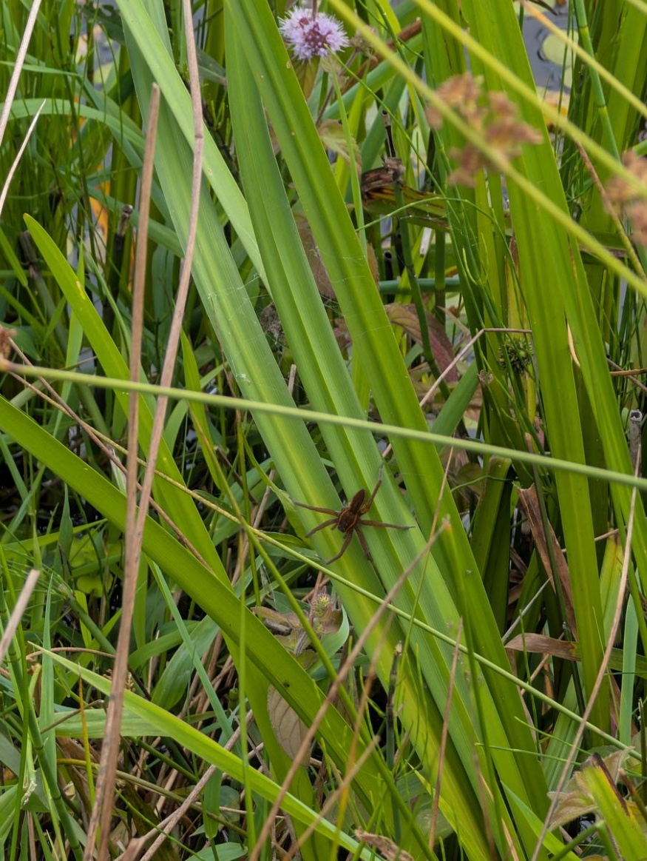

  - Prepared by: Wil J. Heeney t/a Flauna Ecology

  - Tel: 07495 691 888
  - Email: wjheeney@flauna.uk
  - www.flauna.uk
  - Commissioned by: Natural England

Acknowledgments

I would like to thank The British Arachnological Society, Natural England, the Pevensey and Cuckmere Water Level Management Board, and the land owners within the survey area.
1. Summary 5
1.1. Background 5
1.2. Fieldwork 5
1.3. Results 5
1.4. Recommendations 6
2. Introduction 7
2.1. Background 7
2.2. The Fen Raft Spider 7
2.3. Distribution 8
2.4. Previous Surveys 8
2.5. Aims of this Survey 9
3. Methodology 10
3.1. Personnel 10
3.2. Workflow 10
3.3. Task 1 – Survey Design 10
3.4. Task 2 – Data Collection Methods and Testing 12
3.5. Task 3 – The Interactive Report 16
3.6. Task 4 - Volunteer Recording Form 16
4. Results 17
4.1. Survey Dates 17
4.2. Survey Coverage 17
4.3. Spider Distribution in 2025 20
4.4. Comparison with the 1990 Survey 20
4.5. Habitat and Plant Species Associations 21
4.6. Combe Haven — Outlying Population 24
5. Discussion 26
5.1. Water Soldier as Critical Habitat 26
5.2. Survey Comparability and the Access Problems 26
5.3. Population Status - What Can We Actually Say? 27
5.4. Non-Native Plant Species — Limited Concern 28
5.5. Digital Recording for Future Volunteer Monitoring 29
5.6. The Combe Haven Population 29
5.7. Climate Change and Long-term Population Viability 30
5.8. Connectivity, Expansion and Recovery 31
6. References 33
7. Appendix 1 – Langley Sewer at Eastbourne 34
8. Appendix 2 – Pevensey Haven 35
9. Appendix 3 – Horse Eye Sewer 36
10. Appendix 4 – Hurst Haven at Hailsham 37
11. Appendix 5 – Nunnington Stream 38
12. Appendix 6 – Waller Haven between Windmill Hill and Coast 39
13. Appendix 7 – East Stream 40
14. Appendix 8 – Combe Haven 41
15. Appendix 9 – Digital Recording for Future Volunteer Monitoring 42
15.1. Recording Form 42
15.2. Proposed Field Proforma 44

Summary

Background

In June 2025, Natural England in partnership with the British Arachnological Society and the Cuckmere and Pevensey Water Level Management Board commissioned Flauna Ecology to undertake a structured survey of the Fen Raft Spider Dolomedes plantarius across the Pevensey Levels, East Sussex — the first comprehensive survey of the population since 1990 (Jones, 1992).

Fieldwork

Using the presence of nursery webs as the primary indicator of breeding activity, a stratified random sample of 1,166 ditch segments (256.4 km) was selected for survey, stratified by the eight sub-catchments used for drainage management, additionally including all accessible segments surveyed in 1990 for direct comparison. Fieldwork was conducted over 32 days between July and September 2025. Of the selected segments, 289 (24.8%) could not be assessed due to access restrictions, giving a realised survey of 877 segments (193.5 km).

Results

Nursery webs of the Fen Raft Spider were recorded in 80 ditch segments, from 237 nursery web sample locations. A total of 580 nursery webs were recorded, of which 268 (46.2%) were occupied. Direct comparison with the 1990 survey was possible for 376 segments surveyed in both years and accessible in 2025; nursery webs were present in both years at 22 segments, in 1990 only at 76, and in 2025 only at 22, a statistically significant net reduction (McNemar's test, p < 0.0001). However, this comparison should be interpreted with caution: 62 segments with 1990 nursery web records could not be accessed in 2025, the majority lying within the Pevensey Levels NNR where conditions remain favourable, and the proportion of 1990-positive segments on which nursery webs were also recorded in 2025 (22.4%) should be treated as a minimum estimate. Nursery webs were additionally recorded at 36 segments in previously unsampled areas of the network.

Nursery webs were recorded across six of the eight survey sub-catchments, with occurrence concentrated in the Pevensey Haven and Horse Eye Sewer sub-catchments. In the Langley Sewer sub-catchment, no nursery webs were detected on formally surveyed segments, though incidental records of nursery webs were made on unsurveyed segments while passing through the area. No nursery webs were detected in Nunnington Stream, and the Ashbourne and Hugletts Stream sub-catchment was not surveyed.

Water Soldier Stratiotes aloides was the strongest predictor of nursery web presence (OR = 8.38, p < 0.0001), with 42.9% of segments where any Water Soldier was present recording nursery webs, compared to 8.2% without. The number of nursery webs per sample was strongly linked to Water Soldier density (Spearman ρ = 0.72, p < 0.0001), and 96.5% of webs in Water Soldier segments were constructed directly over the plant. Neither NZ Pygmyweed Crassula helmsii nor Floating Pennywort Hydrocotyle ranunculoides showed a negative association with nursery web presence at current densities, though nursery webs within dense Floating Pennywort growth may be substantially under-recorded due to poor visibility.

A reconnaissance visit to the Combe Haven area, approximately 10 km west of the main Pevensey Levels, reconfirmed the presence of the Fen Raft Spider with a single occupied nursery web recorded from 43 segments surveyed across 7.86 km. The site presents substantially more challenging survey conditions than the main Pevensey Levels, and a dedicated repeat survey is recommended to characterise the population more fully.

Recommendations

Key recommendations include:
      - Resumption of systematic monitoring within the SWT reserve and initiation of a monitoring scheme for the Levels as a whole of systematic monitoring
      - Targeted follow-up of the 76 segments where nursery webs were present only in 1990
      - Rotational ditch management across Pevensey Levels to address the observed reed and scrub encroachment seen on some ditches
      - Maintenance and extension of Water Soldier stands
      - Development of a standardised digital recording form via iRecord to support future volunteer monitoring (Appendix 9)
      - In the longer term, expansion of the translocation programme to establish additional self-sustaining populations at geographically distinct sites, given the threats posed by summer drought and coastal squeeze

Introduction

Background

In June 2025, Natural England in partnership with the British Arachnological Society (BAS) and the Cuckmere and Pevensey Water Level Management Board, commissioned Wil J. Heeney (Flauna Ecology), to undertake a survey of the Fen Raft Spider Dolomedes plantarius across the Pevensey Levels.

The Pevensey Levels holds the most extensive remnant population of the Fen Raft Spider. This population has not been subject to a structured survey since 1990 (Jones, 1992).

The Fen Raft Spider

The Fen Raft Spider Dolomedes plantarius is one of the largest spiders in Britain, with adults measuring up to 23mm long. They are distinctive spiders, only being confused with the very similar Raft Spider Dolomedes fimbriatus. Both raft spiders are large, usually with characteristic white, cream, or yellow bands down the black, or brown, carapace and abdomen. Habitat preference helps separate the two species of raft spider; D. plantarius is usually found in lowland, neutral to alkaline, wetlands while D. fimbriatus is found in upland acid mires and lowland wet heaths. However, separating the two raft spider species is only confidently done using microscopic characteristics of the genitalia, or sequencing DNA. The Pevensey Levels population, in typical D. plantarius habitat, was first correctly identified in 1988 (Kirby 1990). D. fimbriatus has not been recorded from the Pevensey Levels.

The Fen Raft Spider is a semi-aquatic predator, hunting from the water surface using vibration detection to locate prey including invertebrates and occasionally small fish or tadpoles (Bristowe 1958). Breeding occurs during summer, with females constructing a characteristic nursery web within emergent or floating vegetation to protect their egg sac and emerging spiderlings (Smith 2020).

Distribution

Three natural populations of the Fen Raft Spider are currently known to exist in Britain:
      - Redgrave and Lopham Fen (Duffey, 1958)
      - The Pevensey Levels (Kirby 1990)
      - A disused canal near Swansea and nearby Crymlyn Bog National Nature Reserve

There have also been four successful translocated populations established in the Norfolk Broads since 2010, at sites selected for the presence of Water Soldier and suitable grazing marsh habitat. The translocations were carried out as part of a collaborative conservation programme and have been monitored since establishment (Smith et al. 2013). These populations have since expanded beyond the original release ditches, demonstrating that the species can establish and spread in suitable habitat when founding populations are sufficient and management is sympathetic.

Previous Surveys

The only previous broad-scale survey of the distribution of Fen Raft Spider on the Pevensey Levels was carried out between August and early October in 1990 (Jones 1992). Commissioned by English Nature (now Natural England), it followed the first formal description of Fen Raft Spider from the Pevensey Levels two years earlier (Kirby 1990). Around 90 km of defined ditch segments were surveyed using nursery webs as the primary metric. Samples were concentrated within the Pevensey Levels SSSI but included a selection of peripheral areas beyond the SSSI, together with small areas of grazing marsh to the west of the Pevensey Levels and around Eastbourne to try to delineate the extent of occurrence. There was no randomisation or other standardised sampling strategy. As in the present survey, ditches were excluded that were difficult to access, or that prior investigation had shown to be unsuitable due to being very overgrown or dry.

The 1990 survey included detailed recording of biotic and physical habitat features for 140 ditch segments (although the data have survived for only 71 of these) where Fen Raft Spider was found, but not for those where it appeared to be absent. The data were recorded in the part of the ditch where nurseries were most abundant.

Aims of this Survey

Due to the Pevensey Levels population of the Fen Raft Spider not being subject to a comprehensive survey since the early 1990s, a brief was produced by Natural England alongside Helen Smith, a specialist in the Fen Raft Spider. This brief described the aims of the survey:
      - To survey the Pevensey Levels ditch network, targeting 50% coverage of the estimated 500–700 km of waterways, during the spider's breeding season (July–September).
      - To compare the 2025 survey results with the ditches surveyed in 1990 (Jones, 1992).
      - To produce written and interactive reports of the survey findings.
      - To present the findings to the Pevensey Levels Farm Cluster meeting to support landowner engagement in the conservation of the Fen Raft Spider
      - To develop a standardised digital recording form to support future volunteer monitoring of the Fen Raft Spider.

Methodology

Personnel

The surveying work and report have been carried out by Wil J. Heeney, from Flauna Ecology, who is an experienced ecologist specialising in invertebrates.

Workflow

Given the scale of the survey and the volumes of data to be collected and analysed, the work was structured around four principal tasks:
      - Task 1 – Survey Design
      - Task 2 – Data Collection
      - Task 3 – Producing the traditional and interactive report
      - Task 4 – Volunteer Recording Form

Task 1 – Survey Design

The extent of the survey area made it impractical to survey all ditches, necessitating the use of stratified random sampling. To ensure an even and unbiased spread of samples, the survey was stratified by the eight sub-catchments used for drainage management across the Pevensey Levels.

No shapefile of the complete ditch network was available for the Pevensey Levels; the network was therefore mapped from scratch using aerial photography in QGIS 3.14 (QGIS, 2026). Environment Agency shapefiles provided sub-catchment boundaries and main waterway features for the following sub-catchments (Figure 3.1):
      - Ashbourne and Hugletts Stream (6)
      - East Stream (8)
      - Horse Eye Sewer (3)
      - Hurst Haven at Hailsham (4)
      - Langley Sewer at Eastbourne (1)
      - Nunnington Stream (5)
      - Pevensey Haven (2)
      - Waller Haven between Windmill Hill and Coast (7)

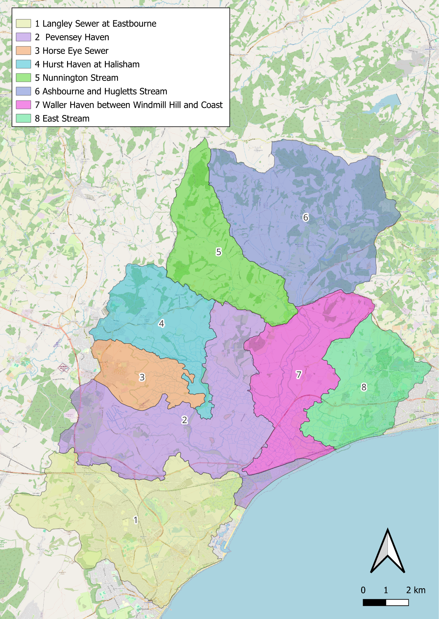
Figure 3.1. Sub-catchment areas within the survey area.

Each sub-catchment area was given a number (one to eight) which is denoted by the numbers within brackets in the above list. The main waterways within these sub-catchments were then mapped into segments, numbering them with the prefix of the sub-catchment, e.g., for Sub-catchment 1, the numbering would follow 10001, 10002, 10003, etc. A segment was defined as a length of waterway along a field edge, or between two features such as hedgerows or junctions between ditch segments.

After mapping the main waterways, satellite imagery was used to map the entire ditch system within those sub-catchments, again numbering the segments with the prefix of the sub-catchment.

The 1990 survey map was provided as a georeferenced image, which was overlaid onto the mapped ditch network in QGIS to identify the previously surveyed segments as accurately as possible.

The 1990 survey is described in §2.4; those survey ditches were treated as a priority in the 2025 survey design. Of the 246 segments where nursery webs were recorded in 1990, 160 were included in the stratified random sample for direct comparison; the remaining 86, distributed across six sub-catchments, were not drawn in the sample.

A reconnaissance survey of the Combe Haven area was also included. Combe Haven lies approximately 10 km west of the main Pevensey Levels survey area, separated from it by the extensive built-up area of Bexhill-on-Sea, with higher ground to the north. The Fen Raft Spider population was first recorded in June 2022 at TQ 761 103 and has not previously been subject to a baseline survey. The site falls outside the eight sub-catchments forming the primary survey design and was treated as a separate, opportunistic component of the fieldwork (see §4.6 and Appendix 8).

Task 2 – Data Collection Methods and Testing

To facilitate the accurate and timely collection of data in the field, and to allow for a streamlined process for data analysis, the Coreo app (Natural Apptitude, 2026) was utilised. Coreo is a web platform and mobile app designed by ecologists for data to be taken by ecologists in the field using libraries of survey templates. The user is also able to create their own customised survey forms. Three survey forms were created; the details are given in the tables below.

The survey was conducted between July and September 2025. Each ditch segment was visited once during this period. Fen Raft Spiders can produce two, or occasionally three broods during the season, with around five weeks between them. As a result, the number of nursery webs detectable on an individual ditch segment at any point in the season can vary substantially (Smith 2020). To reduce the risk of sampling any one stratum only at a peak or trough in breeding activity, segments within each sub-catchment stratum were visited across the full survey period rather than being concentrated into a single visit window.

Segments were recorded as inaccessible where cattle were present in the field, where no effective ditch existed at the mapped location, or where the segment could not be reached from the survey route without crossing a waterway requiring a significant detour. No substitute segments were used. While working through each area on subsequent survey days, previously inaccessible segments were re-checked opportunistically and surveyed where conditions had changed. Inaccessible segments within the Pevensey Levels NNR were not prioritised for revisits, as the reserve is designated for the Fen Raft Spider and habitat management remains favourable.
Table 3.1. Data collection forms used in the Coreo survey application.
Segment Mapping (Form 1)
Data Prompt | Data Entry Field
Date | Auto Populated in Field
Segment Line data | Mappable in Field
Segment Type | Ditch / Main Waterway
Previously Surveyed | Yes / No
Segment Number | Enter in Field
Segment Information (Form 2)
Data Prompt | Data Entry Field
Location Point Data | Mappable in Field
What3Words | Auto Populated in Field
British National Grid | Auto Populated in Field
Ordnance Survey Grid Reference | Auto Populated in Field
Segment Type | Ditch / Main Waterway
Segment Number | Enter in Field
Segment Valid | Yes / No
Segment Valid Notes | Description of above
Est. Width at Mid-Point Exclu. Margins | Enter in Field (m)
Est. Width at Mid-Point Inclu. Margins | Enter in Field (m)
Depth of Freeboard | Enter in Field (m)
Land use either side | Gardens and Parks, Arable, Pasture, Urban, Track / Road, Sewer / Road, Woodland, Scrub, Hardstanding
Presence of Water Soldier | 1 Dense Throughout, 2 Locally Dense, 3 Sparse, 4 Present but Rosettes Submerged, 5 Absent
Presence of New Zealand Pygmyweed | 1 Few and Sparse, 2 Locally Dense, 3 Dominant Throughout, 4 Absent
Presence of Floating Pennywort | 1 Few and Sparse, 2 Locally Dense, 3 Dominant Throughout, 4 Absent
Photo | Take in Field (geo referenced)
Notes | Enter in Field
Fen Raft Spider Sightings (Form 3)
Data Prompt | Data Entry Field
Location Point Data | Mappable in Field
What3Words | Auto Populated in Field
BritNatGrid | Auto Populated in Field
OSNG | Auto Populated in Field
Date | Auto Populated in Field
Segment Type | Ditch / Main Waterway
Segment Number | Enter in Field
Number of Webs | Enter in Field
Number of Occupied Webs | Enter in Field
Number of Webs Supported by Water Soldier | Enter in Field
Photo | Take in Field (geo referenced)
Notes | Enter in Field

Fen Raft Spider nursery web data (Table 3.1: Form 3) was collected as point data. When a segment was surveyed, and a nursery web was encountered, the following 4m of the segment was also checked for nursery webs. The tally of nursery webs, occupied /unoccupied, and supported or not, by Water Soldier, was taken in this 4m sample, before the information was attached to the point datum placed approximately in the middle of that 4m sample. A photograph was taken of a representative nursery web, or several nursery webs if the situation allowed to do so, before repeating the process from the end of that 4m sample, if nursery webs continued to be present.

Environmental information (table 3.1: Form 2) was taken as point data at approximately the middle of every surveyed segment whether nursery webs were present or not. Information taken was the segment number, the width including and excluding the margins, the depth of the freeboard, and the land use either side. The presence and density, or absence, of three non-native plant species, New Zealand Pygmyweed Crassula helmsii, Floating Pennywort Hydrocotyle ranunculoides, and Water Soldier Stratiotes aloides was also recorded using categorical density scores for the entire length of the segment (Table 3.1, Form 2). Also taken was a geographically referenced photograph.

Fen Raft Spider Segment Mapping (table 3.1: Form 1) was carried out in the field using the Coreo App in the form of mapping line data. This was taken to keep track of the progress of the survey in the field.

All statistical analyses were carried out in R (R Core Team, 2025). Associations between nursery web presence/absence and habitat variables (Water Soldier, Floating Pennywort, NZ Pygmyweed, and segment length) were tested using logistic regression, with odds ratios (OR) and 95% confidence intervals reported where significant. Fisher's exact test was used for categorical habitat variables where cell counts were low. The significance of population change between 1990 and 2025 at directly comparable accessible sites was assessed using McNemar's test for paired presence/absence data. Differences in web sample size between Water Soldier and non-Water Soldier segments were tested using the Mann-Whitney U test. The relationship between Water Soldier density score and web sample size was assessed using Spearman's rank correlation. A significance threshold of p < 0.05 was applied throughout.

Task 3 – The Interactive Report

To maximise the accessibility and utility of the survey findings for a non-specialist audience, the results were compiled into an interactive digital report alongside the written report. The interactive report was designed as a public-facing tool, intended to support engagement with landowners, volunteers, and conservation stakeholders across the Pevensey Levels.

The report was built as a self-contained HTML file using the open-source Leaflet.js mapping library, requiring no internet connection or specialist software to operate. All 14 data layers — spanning 1990 and 2025 nursery web records, habitat data, and comparison categories — are accessible within the report, with quick-view presets allowing users to switch between thematic views in a single click. Every surveyed segment and nursery web record is interactive, with clickable popups providing segment-level data including survey outcomes, habitat scores, and where available, georeferenced photographic evidence collected during the 2025 survey. The interactive report is available from Natural England on request.

Task 4 - Volunteer Recording Form

A further deliverable identified during the project was the development of a standardised digital recording form to support future volunteer-led monitoring of the Fen Raft Spider. The aim is to provide a repeatable, low-barrier recording methodology that generates data directly compatible with national biodiversity databases, reducing transcription error and coordinator burden relative to paper-based approaches.

The iRecord platform, managed by the Biological Records Centre (BRC), has been identified as the proposed solution, offering a well-established infrastructure for species recording by volunteers with automatic data verification and submission to national datasets. Development of a bespoke Fen Raft Spider recording form within iRecord is under discussion with BRC.

Results

Survey Dates

Fieldwork was carried out over 32 days between the 5th of July and the 20th of September 2025. Survey dates and weather conditions are given below.
Table 4.1. Survey dates and weather conditions.
Survey Date | Temp | Notes
5th July | 19°C | Dry
6th July | 20°C | Dry
13th July | 25°C | Dry
14th July | 21°C | Dry
15th July | 20°C | Dry
16th July | 24°C | Dry
17th July | 25°C | Dry
20th July | 20°C | Thundery and wet
21st July | 22°C | Thundery and unsettled
22nd July | 22°C | Dry
23rd July | 22°C | Mild with some rain
26th July | 23°C | Dry
27th July | 21°C | Dry
29th July | 21°C | Dry
30th July | 22°C | Dry
3rd Aug | 20°C | Dry
4th Aug | 19°C | Dry
5th Aug | 22°C | Dry
6th Aug | 22°C | Dry
11th Aug | 24°C | Dry
12th Aug | 31°C | Dry
13th Aug | 21°C | Dry
14th Aug | 24°C | Dry
31st Aug | 20°C | Dry
1st Sept | 20°C | Some rain
6th Sept | 23°C | Dry
7th Sept | 24°C | Dry
10th Sept | 17°C | Some rain
11th Sept | 18°C | Some rain
17th Sept | 18°C | Some rain
18th Sept | 19°C | Some rain
20th Sept | 21°C | Dry

Survey Coverage

The 2025 survey selected 1,166 segments (256.4 km) for survey across the eight sub-catchments, representing 46.3% of the total mapped ditch network (540.8 km). Of these, 289 segments (24.8%; 62.9 km) could not be assessed due to access restrictions, predominantly in fields with cattle. The realised survey therefore covered 877 segments (193.5 km), representing 35.8% of the total mapped network (Table 4.2). This compares to 763 segments (165.1 km; 30.3%) surveyed in 1990. Survey coverage by sub-catchment is given in Table 4.3; coverage maps are presented in Appendices 1–7.
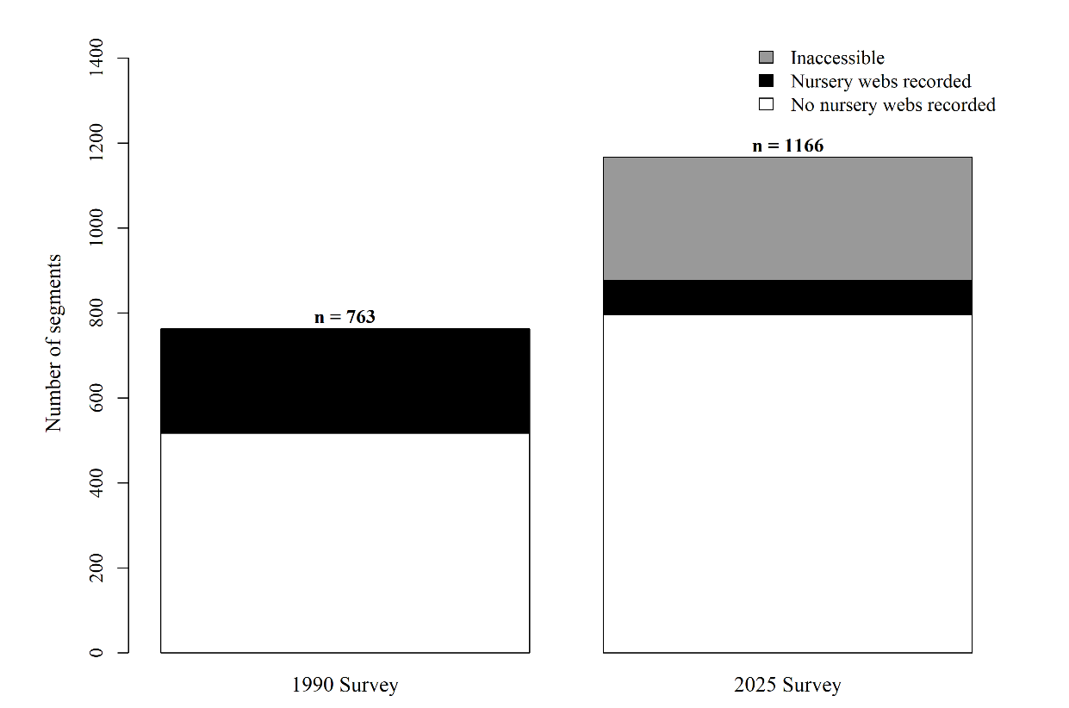
Figure 4.1. Survey coverage in 2025.

Table 4.2. Survey coverage in the 2025 stratified random sample.
Metric | Value
Total mapped ditch network | 540.8 km (2,516 segments)
Selected for survey | 256.4 km (1,166 segments; 46.3% of network)
Inaccessible | 62.9 km (289 segments; 24.8% of selected)
Surveyed | 193.5 km (877 segments; 35.8% of network)
Segments with nursery webs recorded | 80

Table 4.3. Survey coverage by sub-catchment.
Sub-catchment | Total network  (segments) | Total network  (km) | Selected  (segments) | Selected  (km) | Inaccessible  (segments) | Inaccessible  (km) | Surveyed  (segments) | Surveyed  (km) | Segments with  nursery webs
1. Langley Sewer at Eastbourne | 246 | 68.3 | 81 | 22 | 26 | 8.3 | 55 | 13.6 | 0
2. Pevensey Haven | 851 | 186.3 | 439 | 97.4 | 87 | 20.7 | 352 | 76.7 | 48
3. Horse Eye Sewer | 356 | 64.4 | 127 | 24.5 | 21 | 3.6 | 106 | 20.9 | 14
4. Hurst Haven at Hailsham | 266 | 51.9 | 126 | 25.1 | 25 | 4.7 | 101 | 20.4 | 6
5. Nunnington Stream | 64 | 11.9 | 14 | 3.3 | 4 | 1 | 10 | 2.3 | 0
6. Ashbourne and Hugletts Stream | 44 | 10.4 | 0 | 0 | 0 | 0 | 0 | 0 | 0
7. Waller Haven between Windmill Hill and Coast | 426 | 95.9 | 238 | 56.8 | 70 | 14.4 | 168 | 42.4 | 8
8. East Stream | 220 | 43.8 | 98 | 19.4 | 44 | 8 | 54 | 11.4 | 3
9. Combe Haven | 43 | 7.9 | 43 | 7.9 | 12 | 2.1 | 31 | 5.7 | 1
Total | 2516 | 540.8 | 1166 | 256.4 | 289 | 62.9 | 877 | 193.5 | 80

Spider Distribution in 2025

Nursery webs were recorded across six of the eight sub-catchments (Table 4.3), with the great majority concentrated in Pevensey Haven (48 segments) and Horse Eye Sewer (14 segments). Smaller numbers were recorded in Hurst Haven at Hailsham (6), Waller Haven (8), and East Stream (3). No nursery webs were detected on formally surveyed segments in Langley Sewer at Eastbourne, though incidental records of nursery webs were made on unsurveyed segments while passing through the area. No nursery webs were detected in Nunnington Stream, and Ashbourne and Hugletts Stream was not surveyed. Within occupied sub-catchments, records were not evenly spread but clustered in particular stretches of the ditch network, predominantly those supporting Water Soldier. No segments were selected in the Ashbourne and Hugletts Stream sub-catchment due to access and parking constraints encountered during fieldwork.

Nursery webs of the Fen Raft Spider were recorded in 80 ditch segments in 2025, compared to 246 segments in 1990. However, direct comparison between surveys is subject to substantial limitations, discussed fully in §5.2.

A total of 237 nursery web sample locations were recorded. Across these samples, 580 webs were recorded, of which 268 (46.2%) were occupied. Of these, 402 webs (69.3%) were supported by Water Soldier.

Comparison with the 1990 Survey

Comparison outcomes for segments surveyed in both 1990 and 2025 are summarised in Table 4.4. Survey coverage for the 2025 stratified random sample is given in Table 4.2.
Table 4.4. Comparison of ditch segments surveyed in both 1990 and 2025.
Metric | n | %
Segments surveyed in both years, accessible in 2025 | 376
Nursery webs present in both years | 22 | 5.9
Nursery webs present only in 1990 | 76 | 20.2
Nursery webs present only in 2025 | 22 | 5.9
No nursery webs in either year | 256 | 68.1
1990-positive segments not in 2025 survey area | 86
1990-positive segments inaccessible in 2025 | 62

Of the 376 segments surveyed in both 1990 and 2025 that were accessible in 2025, nursery webs were recorded in both years at 22 segments, in 1990 only at 76 segments, and in 2025 only at 22 segments (Table 4.4). A further 62 segments with 1990 nursery web records were within the survey sample but could not be accessed. The remaining 86 segments with 1990 records were not drawn in the 2025 stratified random sample.

At directly comparable sites, significantly fewer segments had nursery webs in 2025 than in 1990 (McNemar's test, p < 0.0001). Nursery webs were lost from 76 segments and gained at 22, a ratio of 3.5:1.

Nursery webs were additionally recorded at 36 segments that were not included in the 1990 survey, distributed across previously unsampled areas of the ditch network.
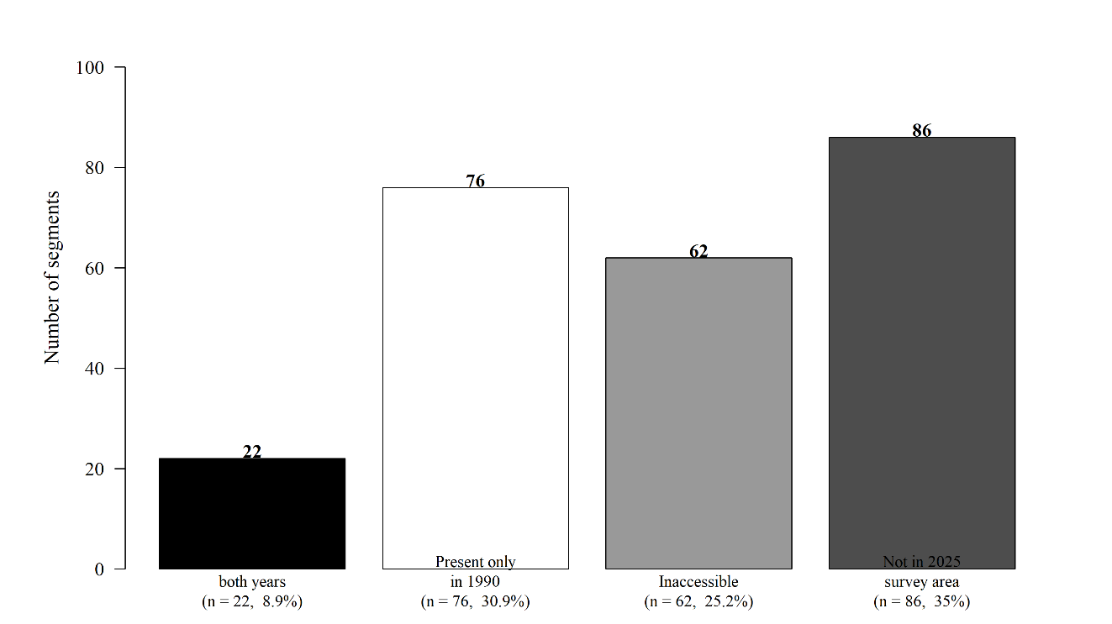
Figure 4.2. Outcomes for 246 segments with nursery web records in 1990.

Habitat and Plant Species Associations

Water Soldier Stratiotes aloides was strongly associated with nursery web presence (Fisher's exact test, OR = 8.38, p < 0.0001). Of segments where any Water Soldier was present, 42.9% (15 of 35) had nursery webs recorded, compared to 8.2% without (64 of 783). Where nursery webs were present, the number of webs per sample was strongly linked to Water Soldier density: samples in segments with Water Soldier contained significantly more webs (mean 3.8, SD = 2.2) than samples without (mean 1.3, SD = 0.8; Mann-Whitney U = 9,900, p < 0.0001). Web counts increased with Water Soldier density (Spearman ρ = 0.72, p < 0.0001).
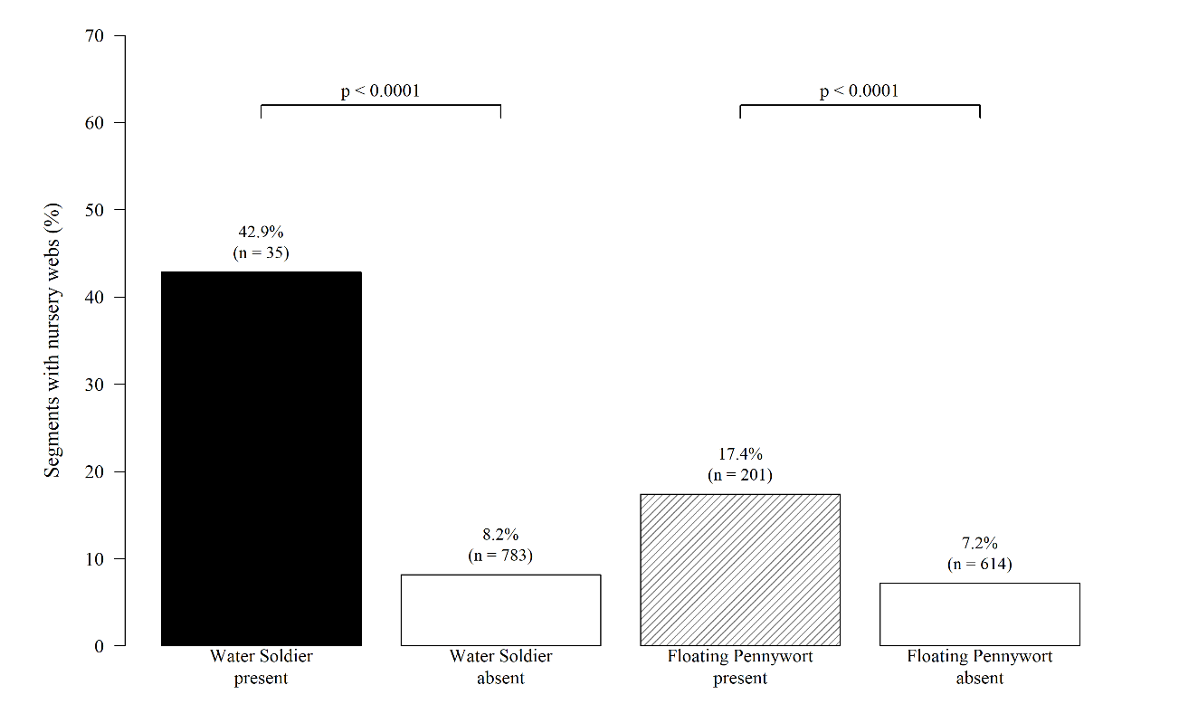
Figure 4.3. Nursery web presence in relation to Water Soldier and Floating Pennywort.
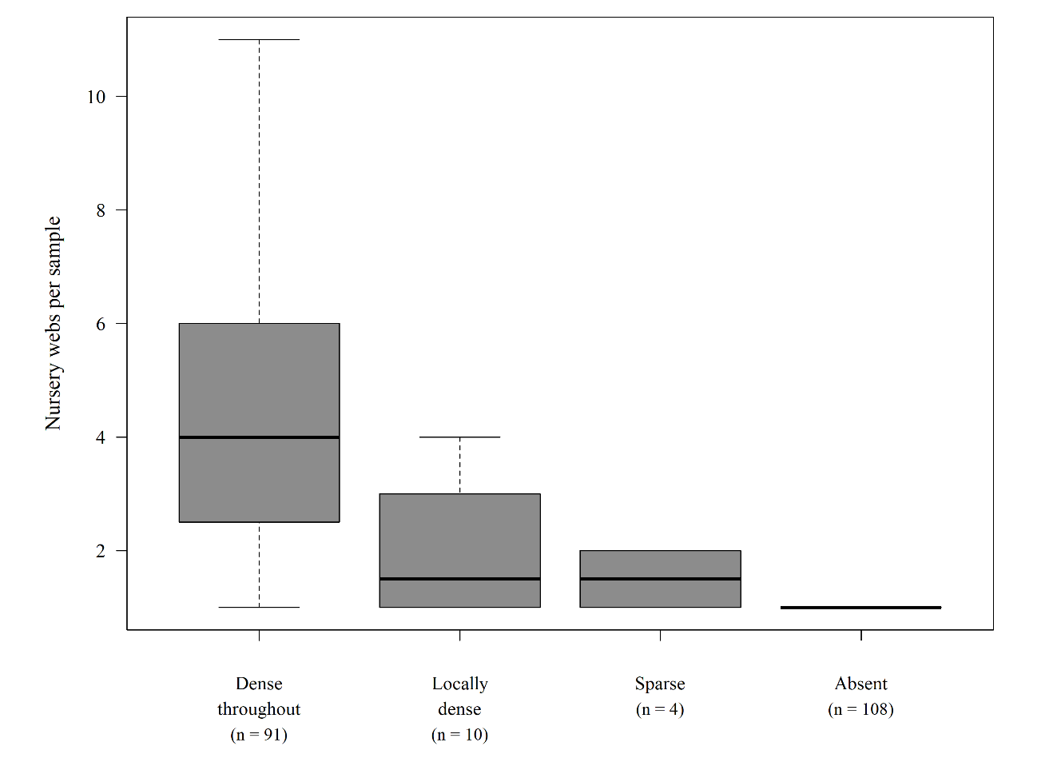
Figure 4.4. Nursery webs per sample by Water Soldier density score.

Of webs recorded in segments where Water Soldier was present, 96.5% were constructed directly over the plant. Nursery web occurrence was spatially concentrated, with 10 segments containing 10 or more webs each.

There was no significant association between nursery web presence and NZ Pygmyweed (Crassula helmsii; Fisher's exact test, p = 0.74), but there was a significant association between nursery web presence and Floating Pennywort (Hydrocotyle ranunculoides; OR = 2.73, p < 0.0001). Segment length was also significantly associated with nursery web presence, with records occurring in longer segments (Mann-Whitney p = 0.0005). In multivariate logistic regression controlling for all four habitat variables simultaneously, Water Soldier remained the strongest predictor of nursery web presence (OR = 12.55, p < 0.0001), followed by Floating Pennywort (OR = 3.57, p < 0.0001) and segment length (OR = 1.45, p = 0.0017); NZ Pygmyweed was not significant (OR = 2.0, p = 0.29). Neither NZ Pygmyweed nor Floating Pennywort showed a negative association with nursery web presence at current densities, though nursery webs within dense Floating Pennywort growth may be substantially under-recorded due to poor visibility.
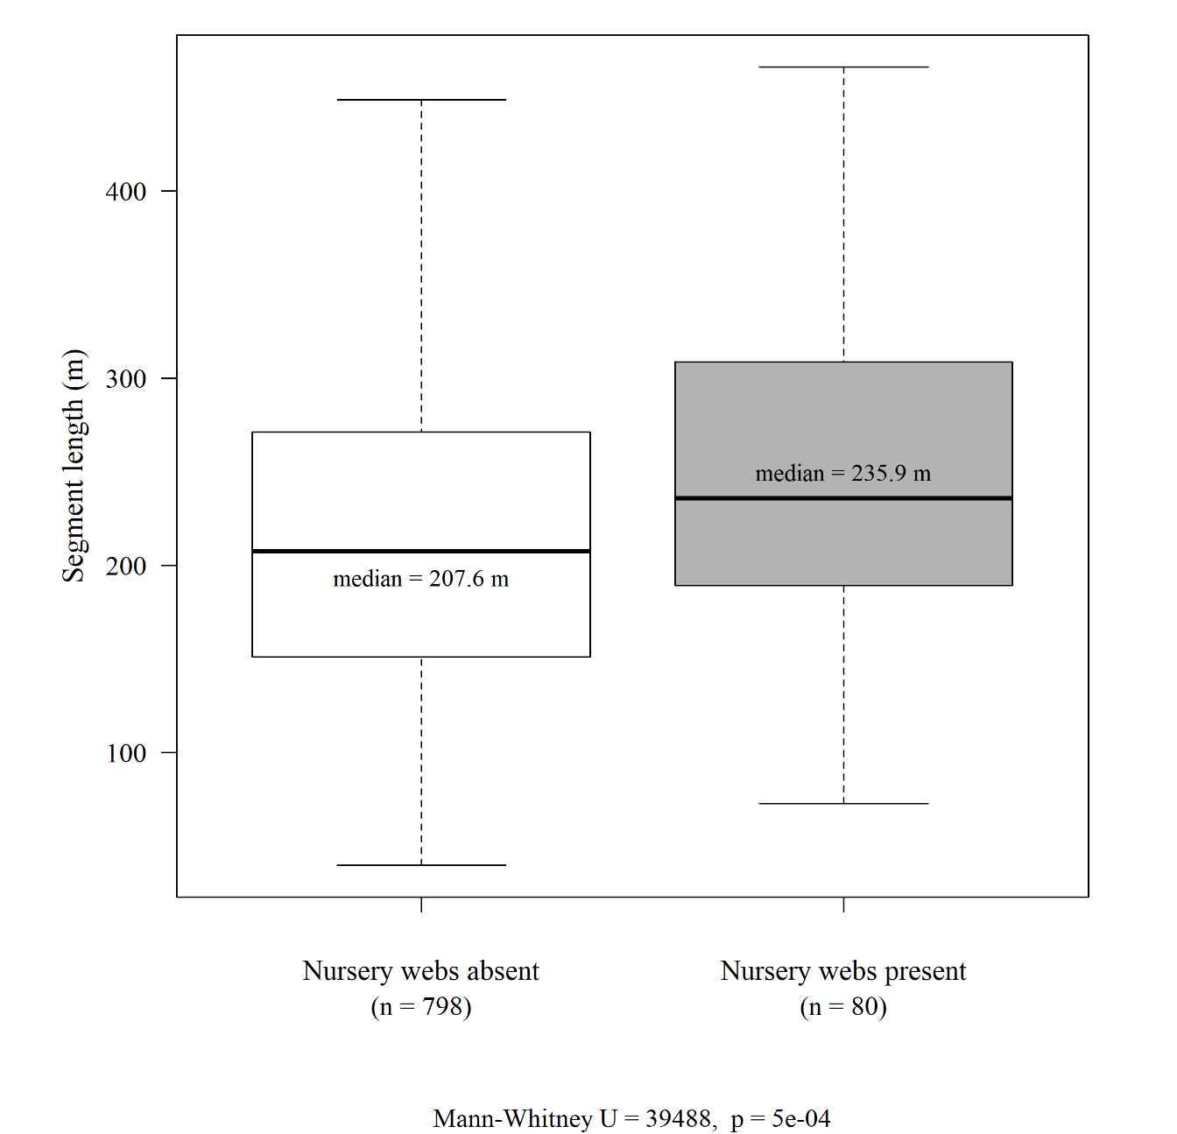
Figure 4.5. Segment length in relation to nursery web presence.

Combe Haven — Outlying Population

A reconnaissance visit to the Combe Haven area was carried out on 20–21 July 2025, surveying 43 ditch segments across 7.86 km of waterway, covering the majority of the accessible ditch network at the site (see Appendix 8).

Survey conditions were substantially more challenging than on the main Levels. A high proportion of segments were heavily scrubbed up, wooded, reedy, or otherwise difficult to assess, with 12 of 43 segments inaccessible. Water Soldier was absent throughout all assessed segments.

The presence of Fen Raft Spiders was reconfirmed in one segment (c003, TQ 761 103), where a single occupied nursery web was recorded at the eastern end of the ditch, adjacent to a bridge. The segment was otherwise largely inaccessible. No further records were made across the remaining 42 segments.

The Combe Haven population was not discovered until 2022 and no baseline survey has been carried out. A dedicated, repeat survey of the area is recommended to better characterise the extent and status of this population.

Discussion

Water Soldier as Critical Habitat

The strong statistical association between Water Soldier presence and nursery web occurrence (OR = 8.38, p < 0.0001), combined with the marked relationship between Water Soldier density and the abundance of nursery webs (Spearman ρ = 0.72, p < 0.0001), confirms Water Soldier as the most important habitat feature influencing the abundance of nursery webs on the Pevensey Levels. The preferential use of the plant as a web substrate is striking: 96.5% of webs recorded in Water Soldier segments were constructed directly over the plant, consistent with active selection.

Despite this strong association, Water Soldier is not a prerequisite for population viability. At Redgrave and Lopham Fen and Crymlyn Bog, Water Soldier is historically absent yet populations persist; in the Norfolk Broads, translocated populations were established in Water Soldier ditches but have since expanded well beyond them. On the Pevensey Levels, conservation management should therefore focus on maintaining and where possible extending existing Water Soldier stands, recognising that these segments support substantially higher nursery web densities, while ensuring that management of the broader ditch network remains sympathetic to the species.

Survey Comparability and the Access Problems

Direct quantitative comparison between the 1990 and 2025 surveys is subject to significant limitations that must be considered when interpreting apparent changes in population size or distribution. The two surveys differed in total coverage (30.3% vs 46.3% of the mapped network), in methodology, and in the degree to which access restrictions affected sampling. Most importantly, 24.8% of the segments selected for survey in 2025 — 289 segments — could not be assessed due to access restrictions, predominantly in fields with cattle. Of the 246 segments where nursery webs were recorded in 1990, 62 (38.8%) fell within this inaccessible area. Most of these lie within the Pevensey Levels NNR, where habitat management is favourable and Water Soldier is present. SWT monitoring in 2012 and 2017 confirmed that this core area continued to support population hotspots relatively recently. The effective loss of these segments from the comparison means that the 22.4% of segments surveyed in 1990 on which nursery webs were also recorded in 2025 should be treated as a minimum estimate.

Population Status - What Can We Actually Say?

The raw comparison — 80 segments with nursery webs in 2025 versus 246 in 1990 — cannot be interpreted as evidence of population decline, given the survey limitations described above. At directly comparable accessible sites, McNemar's test confirmed significantly fewer segments with nursery webs in 2025 than in 1990 (p < 0.0001). However, this figure almost certainly overstates true losses, for several reasons:

First, the 62 inaccessible 1990-positive segments within the NNR remain unassessed, and populations there are likely to have persisted given favourable management conditions. Second, nursery web phenology may account for a proportion of apparent losses — visiting a low-density ditch during a trough between broods could result in a false negative; this risk is discussed in the context of survey timing in §3.4. Third, nursery webs were recorded at 36 segments not included in the 1990 survey, distributed across previously unsampled areas of the network, suggesting the population range may be larger than the 1990 baseline indicated.

Nursery web occurrence was spatially concentrated, with 10 segments each containing 10 or more webs, suggesting the population is distributed as a smaller number of high-density hotspots rather than uniformly across occupied segments. Because most segments support only a low density of nursery webs that can be much more difficult to detect, the population may be more widely distributed and better connected than the accessible survey data alone suggest.

Resurvey is recommended for the 62 inaccessible segments with 1990 nursery web records, the majority of which lie within the Pevensey Levels NNR where the Fen Raft Spider is an SSSI feature. Systematic monitoring within the SWT reserve should be resumed, with a view to initiating a monitoring scheme for the Levels as a whole. Targeted follow-up survey of the 76 segments where nursery webs were present only in 1990 is also recommended, to distinguish genuine population loss from detection failure due to seasonal timing or access constraints.

Field notes recorded at the time of survey provide some additional context for apparent losses. Of the 76 segments where nursery webs were recorded in 1990 but not detected in 2025, 21 (27.6%) were noted as having ditches full of reeds, and a further four (5.3%) were recorded as scrubbed up or scrubbing up. In a small number of additional cases, dense vegetation rendered the survey severely impractical, meaning absence could not be reliably confirmed. Taken together, vegetation encroachment was a documented factor in approximately a third of segments where nursery webs were present only in 1990. Reed encroachment and bankside scrub development reduce the open water surface and emergent vegetation structure on which Fen Raft Spider depends for foraging and web construction and represent a plausible mechanism for genuine local population loss at these sites, independent of detection failure. The remaining two-thirds of apparent loss segments were surveyed without noted habitat concerns, and absence at these sites is less readily explained — seasonal timing, low population density, or genuine local extinction remain possibilities that cannot be separated with single-visit data. Ditch management targeting reed and scrub control at former positive segments should be considered a conservation priority alongside the resurvey recommended above.

Non-Native Plant Species — Limited Concern

Neither NZ Pygmyweed Crassula helmsii nor Floating Pennywort Hydrocotyle ranunculoides showed a negative association with nursery web presence at current densities. There was no significant association between nursery web presence and NZ Pygmyweed (p = 0.74), and no evidence that the species is affecting the population at present. A significant positive association was found with Floating Pennywort (OR = 2.73, p < 0.0001); this most likely reflects the large surface area of emergent structure it creates, in which nursery webs can be constructed, though the data suggest it is much less suitable than Water Soldier given its less robust and less open structure. Detection of nursery webs within dense Floating Pennywort growth may be substantially under-recorded due to poor visibility, and monitoring of both species is recommended if coverage increases.

Water Soldier, despite being non-native in parts of its British range including Sussex, is Nationally Scarce and has never been managed as a problem species on the Pevensey Levels. Given its strong positive association with nursery web density, management should focus on maintaining existing stands rather than control.

Digital Recording for Future Volunteer Monitoring

A standardised digital recording methodology for future volunteer-led monitoring of the Fen Raft Spider on the Pevensey Levels is recommended. The iRecord platform, managed by the Biological Records Centre, has been identified as the most suitable solution, and development of a bespoke recording form is under discussion with BRC. The rationale, practical considerations, and a proposed field proforma are set out in Appendix 9.

The Combe Haven Population

The single record from Combe Haven (segment c003, TQ 761 103) reconfirms the presence of a breeding population at this site, first discovered in June 2022 at the same location. The heavily wooded, scrubby, and reedy character of the site meant that most segments were difficult or impossible to survey effectively from the bankside. Water Soldier has not been recorded at Combe Haven and was absent throughout all assessed segments.

The habitat at Combe Haven differs substantially from the open grazing marsh of the Pevensey Levels. The predominance of shaded, overgrown ditches with dense emergent vegetation is consistent with a site where ditch management has been reduced or absent for an extended period. Under these conditions, the ditch network progressively loses the open water and low-growing emergent vegetation structure that Fen Raft Spider requires for foraging and web construction. The absence of Water Soldier is not in itself a barrier to population persistence — other populations, including the Welsh population at Crymlyn Bog, demonstrate that the species can maintain viable numbers using alternative emergent substrates — but the combination of shading, dense encroaching vegetation, and limited open water surface is likely to be restricting both habitat availability and the detectability of any nursery webs present.

The priority management recommendation for Combe Haven is ditch restoration to increase open water extent and reduce bankside shading. This should focus on: clearance of overhanging scrub and carr woodland from the southern and eastern aspects of key ditch margins to increase light penetration; and rotational cutting of dense emergent reedbed within ditches to maintain open water channels. On the Pevensey Levels, cattle poaching of ditch margins creates wide shelves of tussocky vegetation and small water-filled depressions that provide good habitat for the species; sympathetic grazing management at Combe Haven could deliver similar benefits. These interventions are well-established components of lowland grazing marsh ditch management and are consistent with the habitat management approach applied at the Pevensey Levels NNR.

A dedicated, repeat survey of Combe Haven is recommended as a priority, ideally conducted during peak breeding season (late July to mid-August) when nursery webs are most detectable, and with access by boat or waders where bankside access is impractical. A boat-based survey would substantially increase the proportion of the ditch network that can be assessed and would allow the population extent to be characterised more reliably. Assessment of connectivity with the Pevensey Levels population is unlikely to be resolved by further survey alone, but would require investigation of any lowland ditch connections between the two sites and examination of the historical evidence for when any possible corridor was severed by development.

Climate Change and Long-term Population Viability

The Pevensey Levels population faces a set of climate-related threats that, while not immediately acute, are relevant to any assessment of its long-term viability. The site is a low-lying coastal grazing marsh, much of it below sea level, and is therefore inherently exposed to the compounding risks of sea level rise, increased storm surge frequency, and saline intrusion. Managed realignment and coastal squeeze pressure on the wider Pevensey embayment mean that the hydrological security of the ditch network cannot be assumed to remain stable over decadal timescales. Salinisation of ditch water, even at sub-lethal concentrations, could alter the plant communities on which the spider depends and reduce the suitability of the network for Fen Raft Spider regardless of terrestrial habitat management.

Drought represents a more immediate and already-evident pressure. Survey notes from the 2025 season recorded several segments as dry or with substantially reduced water levels. Fen Raft Spiders ideally require a sufficiently high water table to support their water surface hunting behaviour; they can tolerate lowered water levels, as seen in drought years and arable ditches, but these conditions are likely to result in progressive population decline rather than catastrophic failure. Under projected increases in summer drought frequency and severity, the proportion of the ditch network holding adequate water levels during the critical July to September breeding window is likely to decline. The concentration of breeding activity into a smaller number of high-quality, water-retaining segments — already apparent in the 2025 data — may intensify under these conditions, increasing the vulnerability of the population to local stochastic events.

These pressures reinforce the case for the expansion of the translocation programme beyond the Norfolk Broads, as set out in Action 1 of the Fen Raft Spider Threat Response and Species Action Plan. Establishing additional self-sustaining populations at geographically distinct, climatically resilient sites would reduce the species' dependence on any single location and provide insurance against the long-term deterioration of the Pevensey Levels because of coastal processes or hydrological change. The target of twelve self-sustaining populations identified in the Species Action Plan should be treated as a minimum conservation objective rather than an aspirational endpoint.

Connectivity, Expansion and Recovery

The 2025 survey recorded nursery webs at 36 segments that were not included in the 1990 survey, distributed across previously unsampled areas of the ditch network. While some of these may represent genuine range expansion since 1990, others are more likely to reflect the incomplete coverage of the earlier survey. Regardless of their origin, these records indicate that the population is not confined to the areas where it was historically documented and that the species has the capacity to occupy suitable habitat across a broader extent of the Pevensey Levels than the baseline data alone suggest.

The spatial concentration of breeding activity into a smaller number of high-density hotspots — predominantly those with Water Soldier — raises questions about connectivity between occupied segments. Where suitable ditch habitat is fragmented by long stretches of dry, overgrown, or otherwise unsuitable waterway, dispersal between occupied patches may be limited. Fen Raft Spiders are capable of overland dispersal, particularly as juveniles, but the extent to which the Pevensey Levels ditch network functions as a connected system for the species is unknown. Improving the habitat quality of currently unsatisfactory intervening segments — through water level management, ditch clearance, and the encouragement of Water Soldier where conditions allow — would increase network connectivity and reduce the isolation of occupied patches.

A small number of isolated standing water bodies within and adjacent to the survey area were noted during fieldwork. Where these support suitable emergent vegetation and adequate water quality, they may function as stepping-stone habitats or refugia during drought periods. Their role in the population network warrants investigation, and targeted survey of such features is recommended.

The development of environmental DNA (eDNA) monitoring tools for Fen Raft Spider, identified as a priority action in Natural England's Threatened Spiders Recovery Actions, would substantially improve the ability to assess population connectivity and detect presence in difficult-to-survey habitats such as those encountered at Combe Haven and within inaccessible NNR segments on the Pevensey Levels. eDNA methodology could complement conventional nursery web survey, particularly in early-season assessments or in water bodies where bankside survey is impractical, and its application to the Pevensey Levels population should be considered as a next step in the monitoring programme.

References
Beale, G. & Doberski, J. 1995. Nursery Web Site Selection by Dolomedes plantarius (Clerck, 1757) on the Pevensey Levels, East Sussex. British Arachnological Society Newsletter 95.
Bristowe, W.S. 1958. The World of Spiders. Collins, London.
Duffey, E. 1958. Dolomedes plantarius Clerck, a spider new to Britain, found in the upper Waveney Valley. Transactions of the Norfolk and Norwich Naturalists' Society 18: 1–5.
Jones, E. 1992. The status of Dolomedes plantarius (Clerck) on Pevensey Levels, East Sussex in August 1991. English Nature, Peterborough. [unpublished report]
Kirby, P. 1990. Dolomedes plantarius in East Sussex. Newsletter of the British Arachnological Society 58: 18.
Natural Apptitude. 2026. Coreo [mobile application]. Available at: https://coreo.io
QGIS Development Team. 2026. QGIS Geographic Information System. Open Source Geospatial Foundation. Available at: https://www.qgis.org
R Core Team. 2025. R: A Language and Environment for Statistical Computing. R Foundation for Statistical Computing, Vienna. Available at: https://www.r-project.org
Smith, H. 2020. The Fen Raft Spider: from unknown past to uncertain future. British Wildlife 32, pp. 98–109.
Smith, H., Clarke, D., Heaver, D., Hughes, I., Pearce-Kelly, P. & Sainsbury, T. 2013. Translocation and augmentation of the fen raft spider populations in the UK. In: Soorae, P.S. (ed.) Global reintroduction perspectives: 2013. IUCN/SSC Re-introduction Specialist Group, Abu Dhabi. pp. xiv + 282.

Appendix 1 – Langley Sewer at Eastbourne

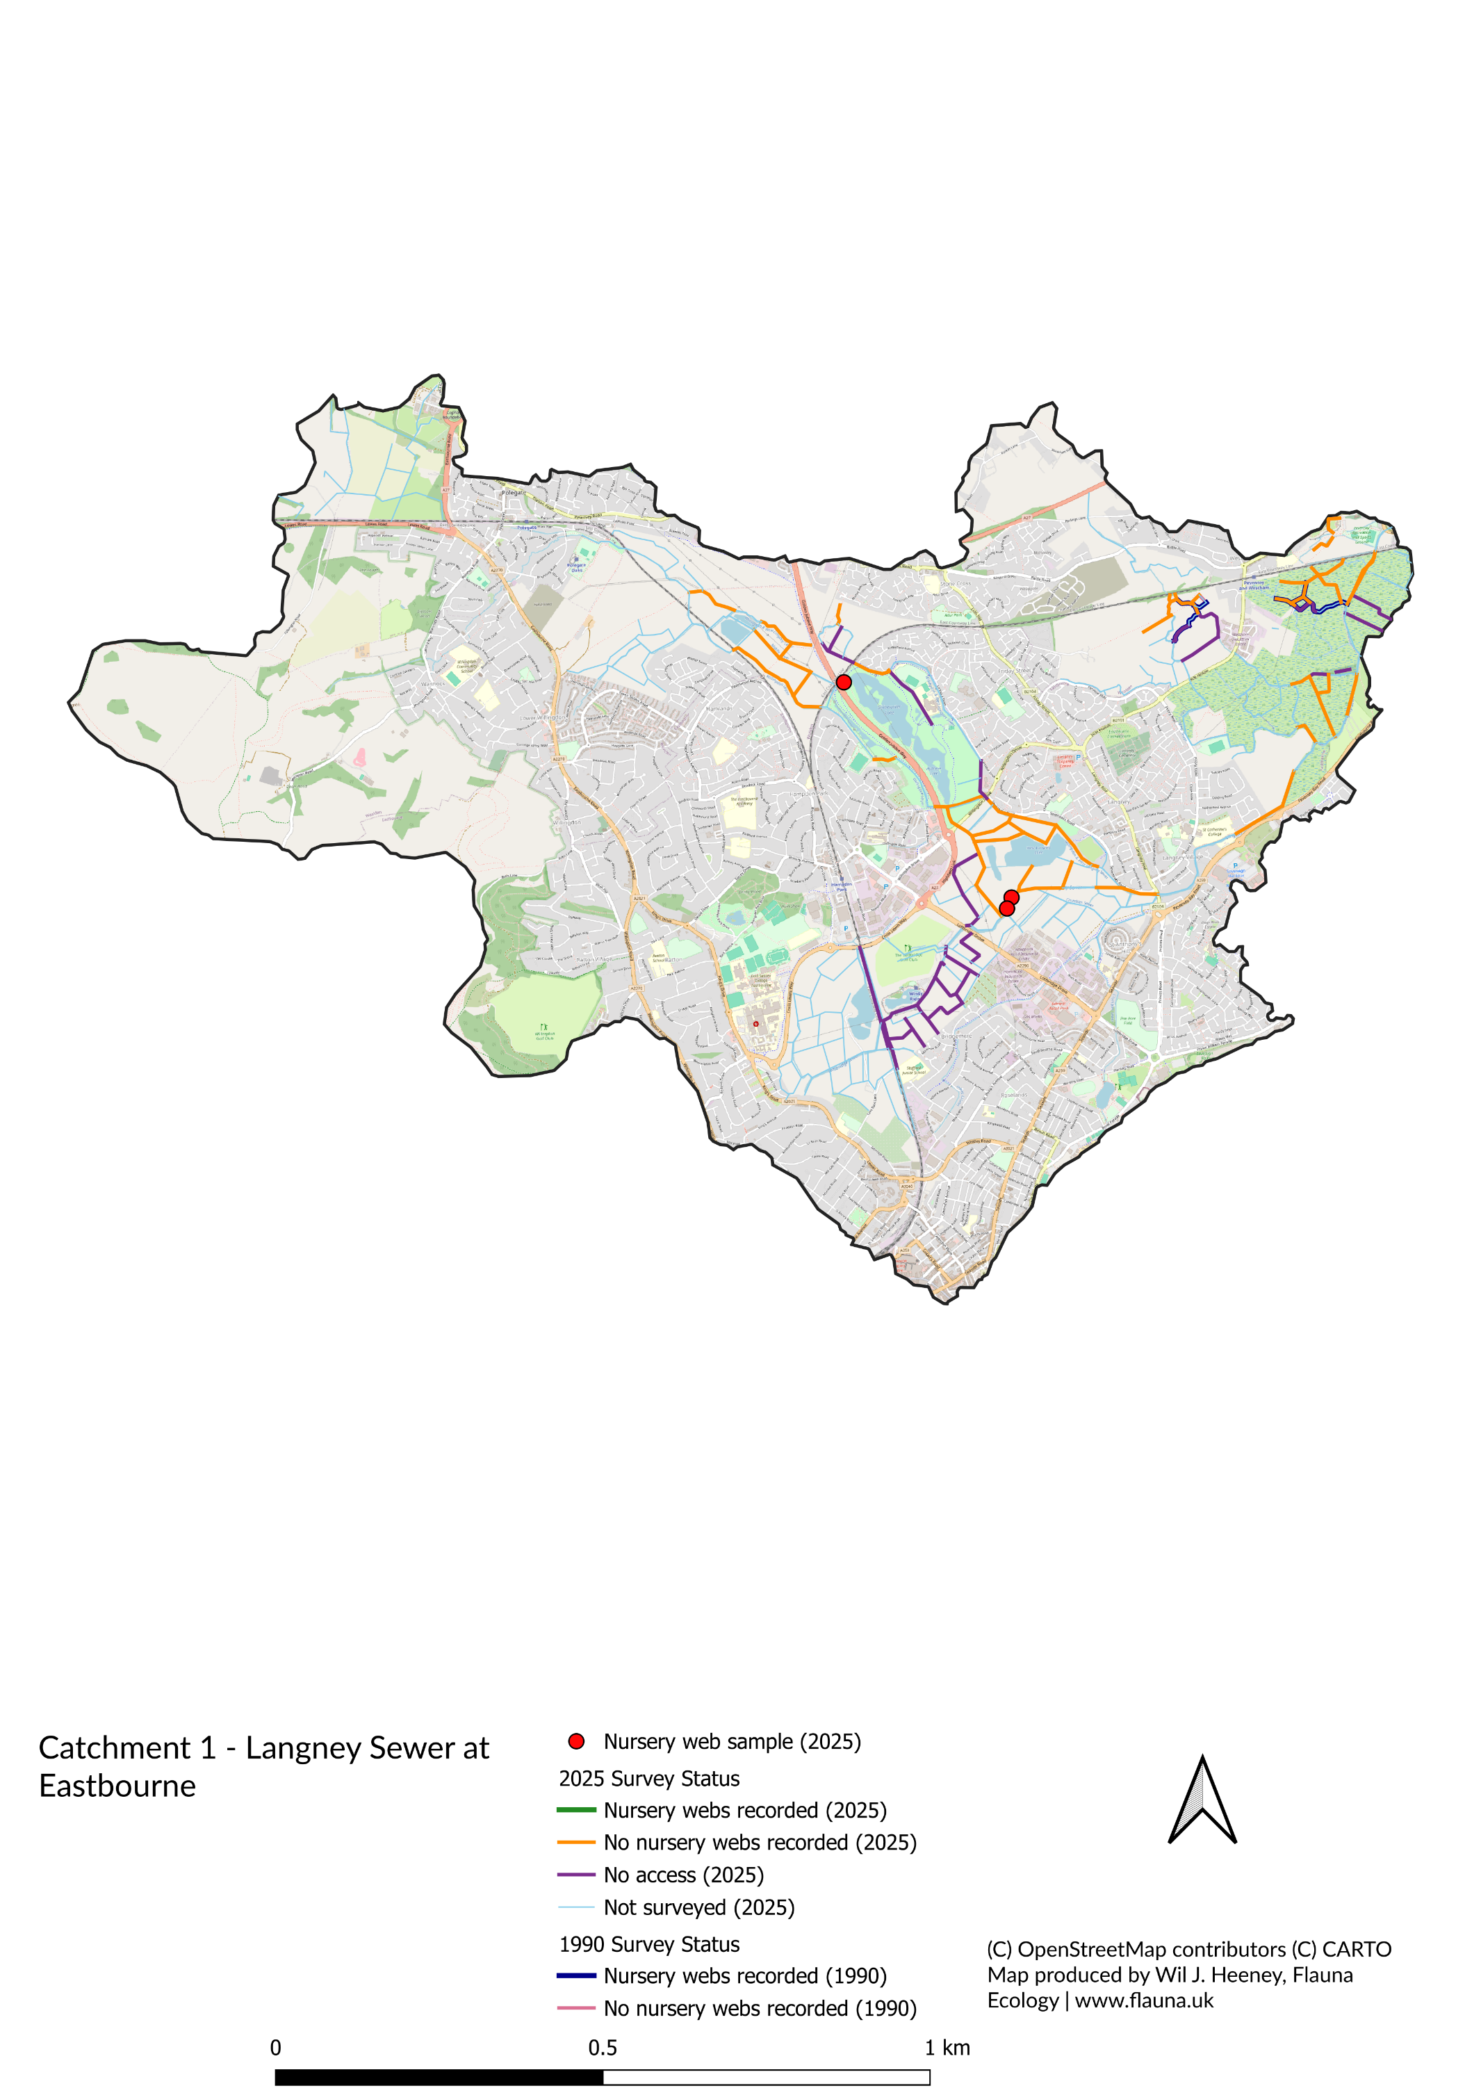
Note: Three nursery web records shown in this sub-catchment were incidental observations on segments outside the formal survey sample.

Appendix 2 – Pevensey Haven
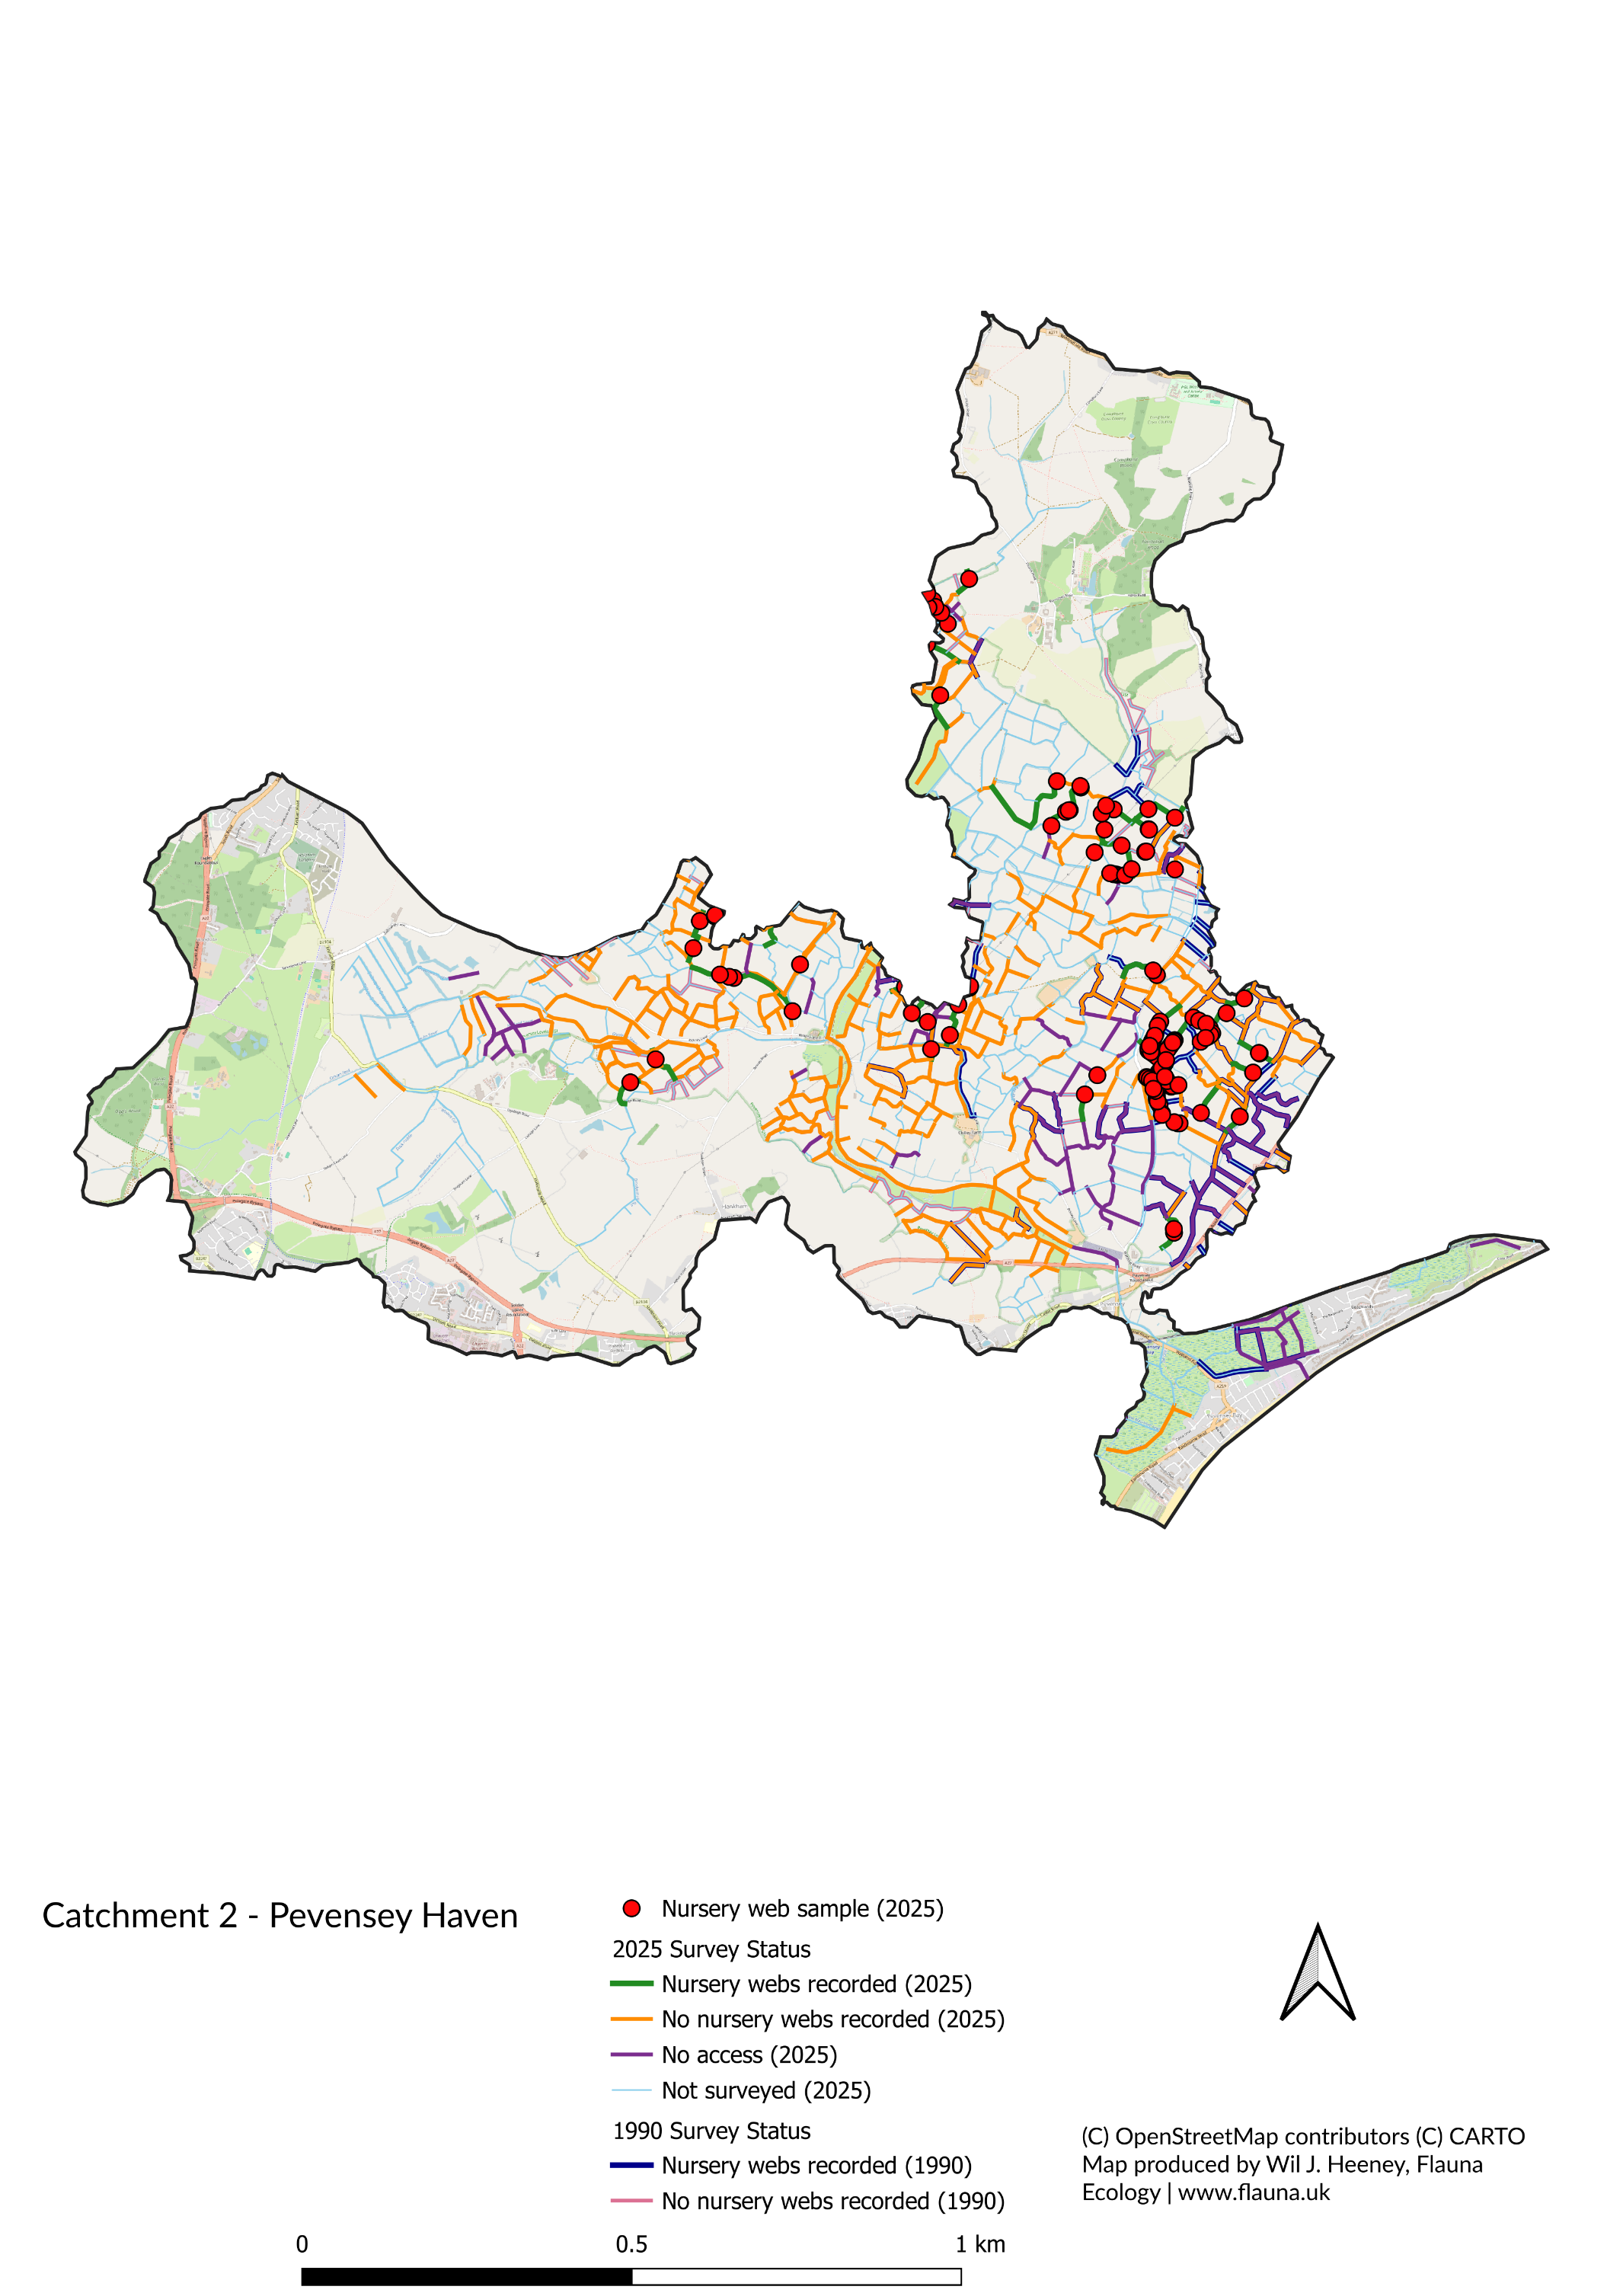

Appendix 3 – Horse Eye Sewer
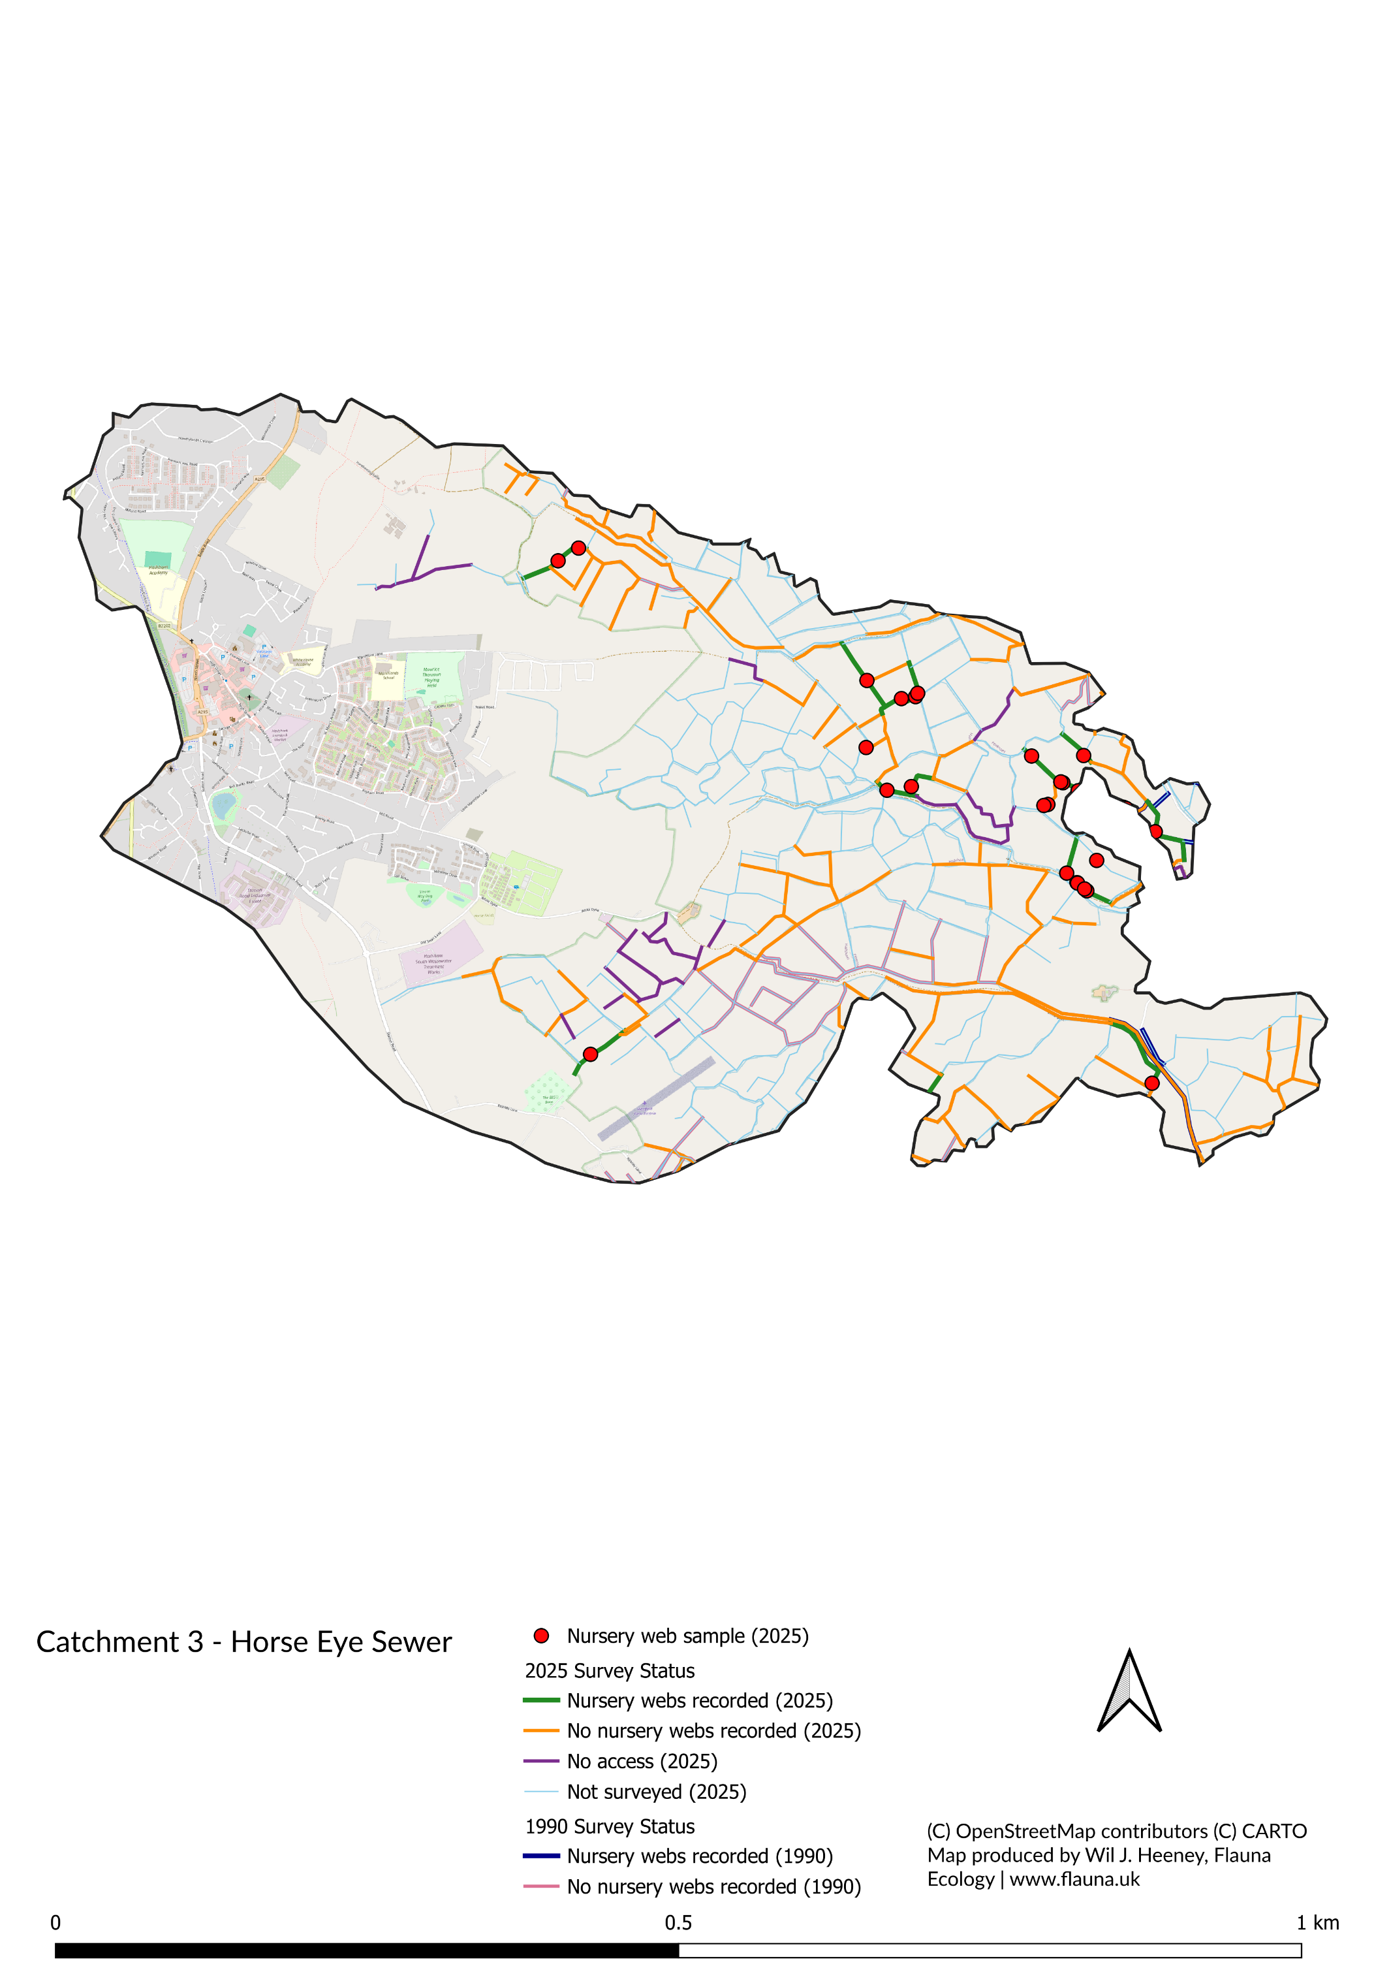

Appendix 4 – Hurst Haven at Hailsham
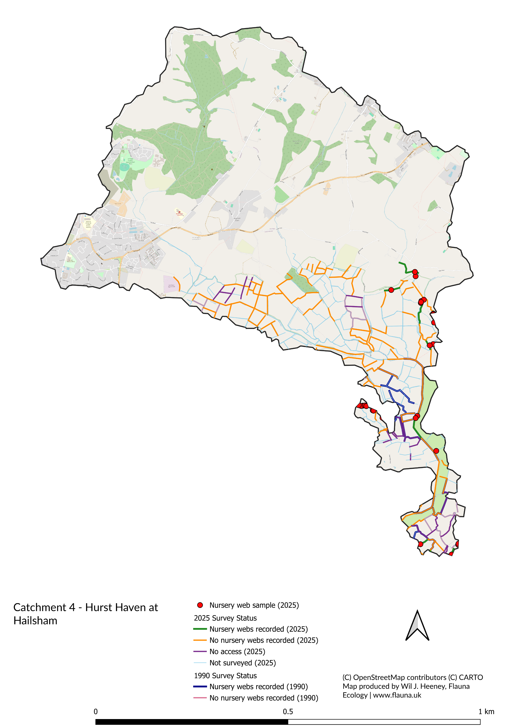

Appendix 5 – Nunnington Stream
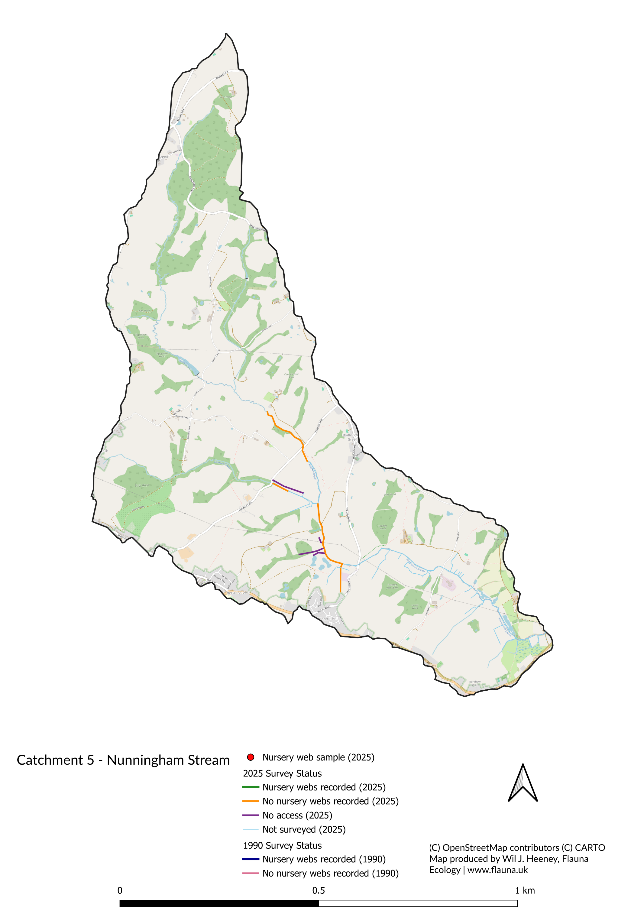

Appendix 6 – Waller Haven between Windmill Hill and Coast
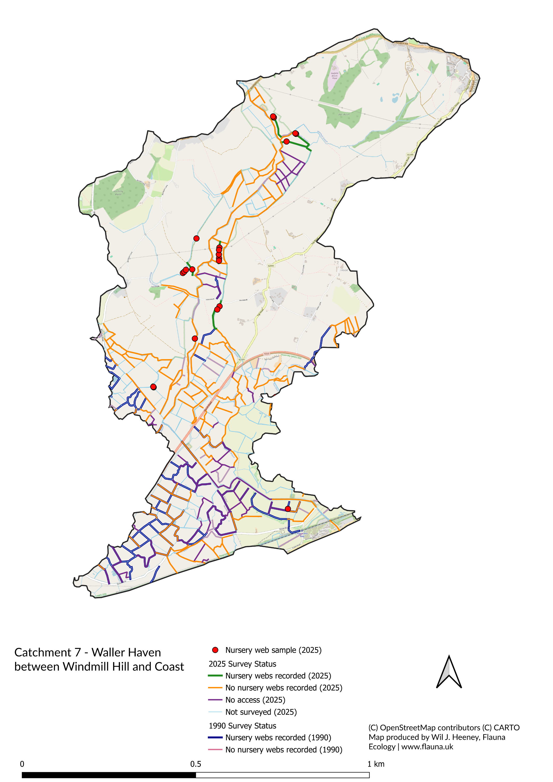

Appendix 7 – East Stream
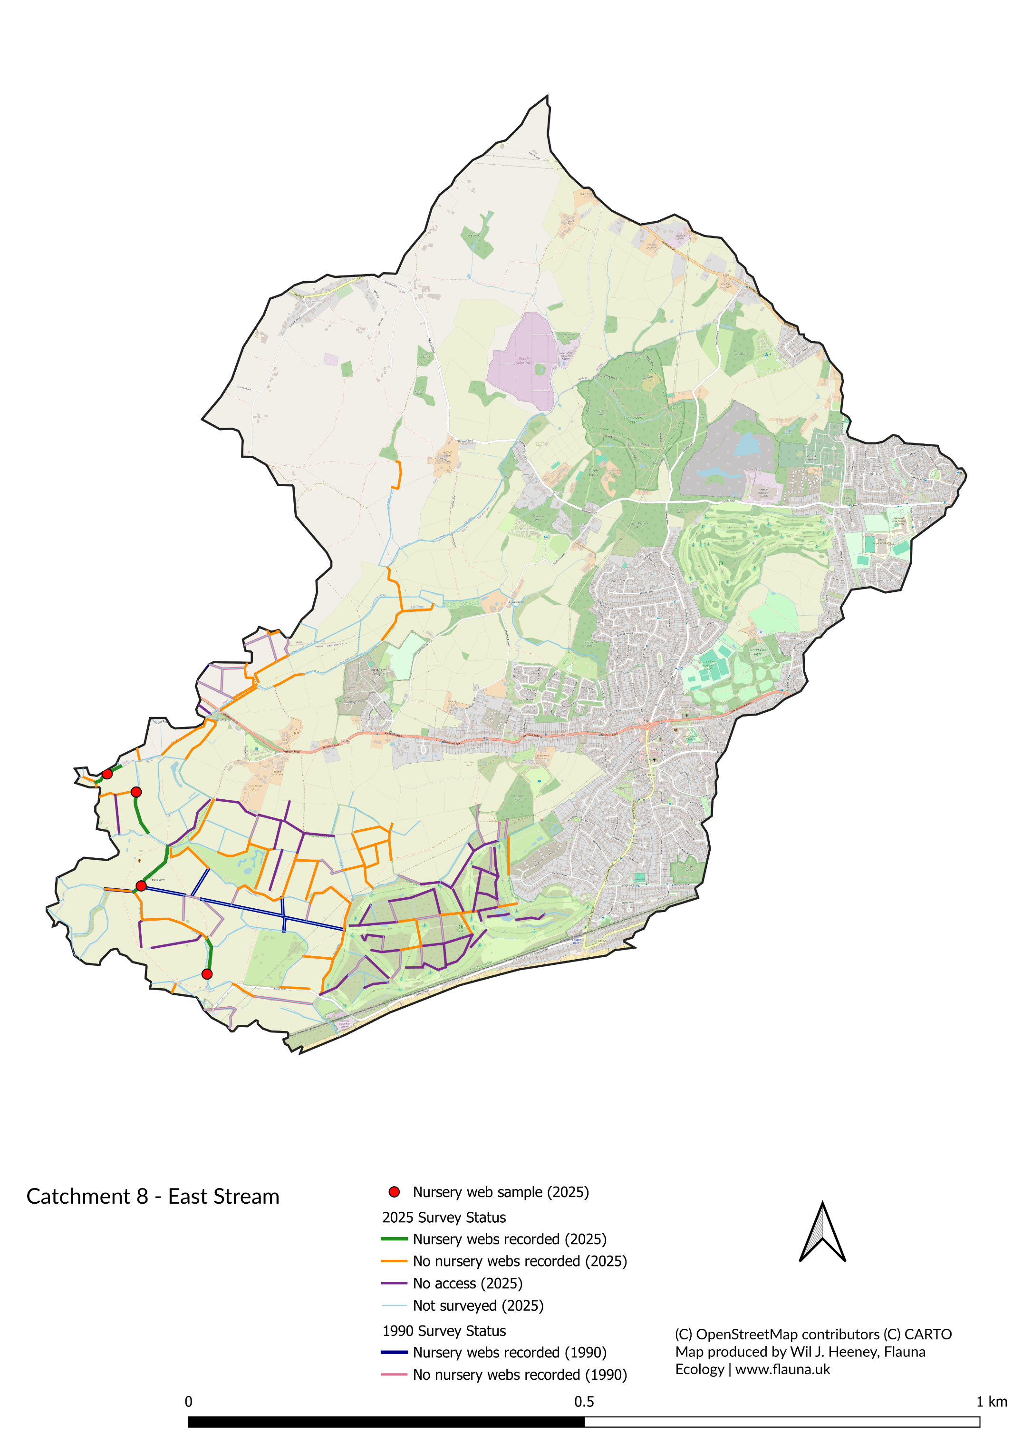

Appendix 8 – Combe Haven
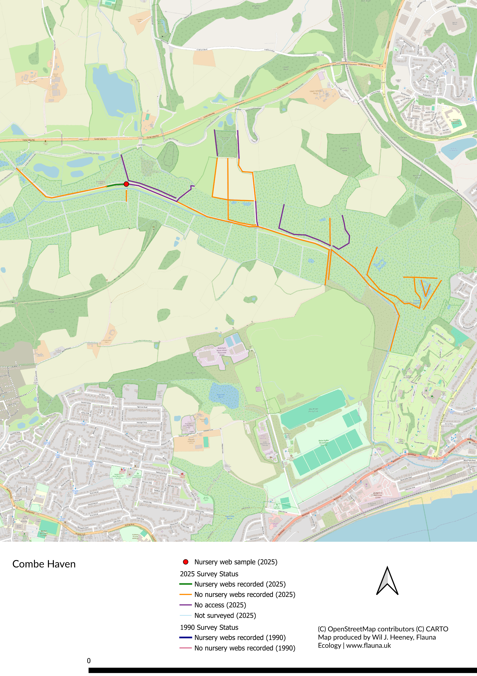

Appendix 9 – Digital Recording for Future Volunteer Monitoring

Recording Form

A deliverable of the project was to determine the most appropriate methodology for future standardised volunteer monitoring of the Fen Raft Spider, and to produce a draft recording form based on the approach developed for the Pevensey Levels survey. This appendix sets out the rationale for digital recording, evaluates the available platforms, and presents a proposed field proforma.
Digital Versus Written Recording

The advantages of digital recording in this context are substantial. Automatic GPS location capture eliminates the inaccuracies inherent in written location references, including What3Words, which field experience has shown to be frequently erroneous. The removal of post-survey data entry eliminates transcription errors entirely and represents a very significant time saving for both volunteers and survey coordinators. Data submitted digitally can be reviewed by the survey coordinator in near real-time, allowing gaps in coverage to be identified and rectified within the survey season. Records submitted via iRecord feed automatically into national biodiversity databases, ensuring long-term data accessibility and comparability across survey years.

The practical challenges of digital recording should not be underestimated, particularly in the context of volunteer surveys. Not all volunteers own smartphones, and those who do may find small-screen data entry slow or uncomfortable, particularly in intense sunshine where screen visibility is poor. GPS accuracy varies between devices, and the risk of kit failure — through battery depletion, water damage, or software issues — is a real consideration in a wetland survey environment. Any requirement for internet connectivity in the field would be an additional constraint, given that mobile signal across the Pevensey Levels is inconsistent. These constraints are not unique to the Pevensey Levels; several other Fen Raft Spider sites, including Redgrave and Lopham Fen and the Norfolk Broads translocation sites, present similar challenges with mobile signal coverage and wetland working conditions, and the recording methodology must be practical across all sites nationally.
Available Platforms for Digital Recording

Several digital recording platforms were considered during the development of this recommendation. The Coreo platform (Natural Apptitude, 2026), used for data collection during the 2025 survey, offers highly customisable survey forms, robust offline functionality, and automatic georeferencing. However, it is a commercial product requiring an organisational subscription, and its adoption for volunteer monitoring across multiple sites and organisations would depend on sustained coordinated funding. It is best suited to professional survey programmes rather than open volunteer recording schemes.

Survey123 for ArcGIS (Esri) and KoboToolbox were also considered. Both offer flexible form design and offline capability, but Survey123 requires an ArcGIS licence, while KoboToolbox, though free, is not integrated with UK biodiversity recording infrastructure and would require manual data transfer to national databases.

The iRecord platform, managed by the Biological Records Centre (BRC), was identified as the most suitable solution. As a publicly funded national infrastructure, it does not carry per-user or per-organisation costs and offers long-term stability independent of commercial funding cycles. Records submitted via iRecord feed automatically into national biodiversity databases, ensuring long-term data accessibility and comparability with other species monitoring programmes. The platform supports custom recording forms and has an established user base among UK ecological volunteers, including a comparable form developed for the Purseweb Spider Atypus affinis.
Next Steps

On balance, the advantages of digital recording — particularly the elimination of location errors and transcription effort, and the ability to monitor survey progress in real time — are considered to outweigh the practical difficulties, though a phased transition with appropriate volunteer support would be advisable. Development of the iRecord form is a recommended next step, and discussions with BRC are ongoing. A paper version of the recording form should be maintained alongside the digital version to accommodate volunteers without smartphones and to provide a fallback where device failure or poor conditions prevent digital recording in the field. Paper records can be entered into iRecord retrospectively by the survey coordinator, ensuring that all data are captured within a single database regardless of the method of collection

Proposed Field Proforma

The following fields are proposed for a future standardised digital recording form. The form is intended to be simple enough for volunteer use while generating data compatible with the segment-based approach used in the 2025 survey and with national biodiversity databases via iRecord.

Table A9.1. Proposed fields for a volunteer Fen Raft Spider recording form.
Field | Entry Type | Notes
Site name | Single select | Pevensey Levels / Redgrave & Lopham Fen / Crymlyn Bog / Castle Marshes / Strumpshaw Fen / Catfield Fen / Sutton Fen / Combe Haven
Date | Auto-populated
Recorder Name | Text
Grid Reference / GPS | Auto-populated | From device GPS
Segment number | Numeric | From pre-assigned map
Weather conditions | Single select | Dry / Overcast / Light rain / Heavy rain / Windy
Search time (minutes) | Numeric | Time spent surveying the segment
Ditch surveyed (y/n) | Single select | If n, record reason below
Reason not surveyed | Single select | Inaccessible / dry / overgrown / other
Nursery webs present (y/n) | Single select
Number of nursery webs | Numeric | If present
Number of occupied webs | Numeric | Containing egg sac or spiderlings
Dominant plant species supporting web | Text / single select | e.g. Water Soldier, reed, Floating Pennywort
Number of webs supported by dominant plant | Numeric | If both present
Photograph | Camera | Representative nursery web
Notes | Free text | Any additional observations

An example of a comparable volunteer recording form developed for the Purseweb Spider (Atypus affinis) is available on the iRecord platform at https://irecord.org.uk/purseweb-spider-recording-monitoring. A similar approach, tailored to the specific requirements of nursery web recording, is recommended for the Fen Raft Spider.

